1. **Can you explain about yourself?**

**Answer**:

I am {your name} and Born & Brought uhgjp in **{say your Location}** (Chennai). I did My BTech in IT Stream during {Years} (2008). I have totally {Number of years} (5+) Years of IT experience and Currently I am supporting {Project Name & Company} as VMware and Windows Server Administrator and My primary responsibility is VMware Virtualization.

1. **Can you explain your infrastructure?**

**Answer**:

Currently I am supporting to xxxx as VMware and Windows administrator and Managing 20+ Physical ESXi Servers and also 400 VM's. Have data center in USA & UK region and supporting 24x7 .

* All 20 Host running with ESXi 5.5 and all running under HP ProLiant BL460c G4 and managing all these with HP C7000 Enclosure with help of OA (Onboard Administrator) and also have good knowledge on Cisco UCS Manager 2.2 (3g), Blade is Cisco B200-M3 & B440-M2.
* Have 2 clusters each cluster have 10 Host
* The cluster configured with HA and DRS with 2 Host Failover tolerance and with DRS Rules
* Managing EMC VNX 5500 and HP SAN EVA 4400 SAN BOXES-----NEED TO UPDATE FEW?



1. **Explain your Roles and Responsibilities (or) Day to Day activities?**

**Answer**:

**ROLES & RESPONSIBILITIES**

Currently am supporting to XXXX Company as a L2+ VMWare & L@ Windows Administrator also have basic knowledge on backup agents, SAN, NAS, and AD. I have hands-on experience on HP Blades & CISCO Blades as well as I can handle DELL & IBM H/W, UCS Manager.

Basically, my responsibilities in VMware as a part of 

1. Build Process
2. Operational Team.

**BUILD LEVEL ACTIVITIES:**

* ESXI Build
* Windows Physical Build
* VM build with help of template & ISO
* Cluster build (HA & DRS configuration)
* Storage adding & N/W switches configuration

**OPERATIONAL RESPONSIBILITIES:**

* Server UP/DOWN issues
* Services UP / DOWN Issues (Service Start & Stop)
* Resources utilization analysis (High Memory, High CPU, High Network Traffic &
* Disk & Data stores issues ( Low disk space in Drive C: D: E: etc... and Datastore Low disk space) 
* Patching of VM & ESXi (Microsoft Security ,Non Critical & Critical Patches. ESXi Patches from VC)
* ESXi upgradation (With help of Update Manager by Baseline)
* Vcenter upgradation (With help of ISO)
* VM tool & VM H/W upgradation. (Need Downtimes)
* Faulty H/W replacement by coordinating with H/W vendors to open the case
* Joining daily operations meeting & joins weekly CAB calls to get the approval from the customer to implement the respective changes.
* Majorly work on the changes incidents service request also part of the problem management to fix the repeat issues.
* Currently am handling environmental upgradation activities 4.0 To 5.5.
* Also I take responsibilities of RCA on call support, escalation matrix.
* Finally I will be more interest on the technical document preparation for the team in daily operations.
* Inventory updates, Firmware updates for daily & quarterly basis.

**HARDWARE QUESTIONS AND ANSWERS**

**(1) Types of Hardware's & Remote Boards?**

Answer**:**

**HP**--**ILO :** (Integrated Lights Out)

**HP RACK MODELS :** ProliantDL 380p Gen8, HP Proliant DL380 G9, HP DL 380e G8 ,DL 580 G9.

**HP BLADE MODEL :** BL460CG9, BL460CG6

**DELL--DRAC :** (Dell Remote Access Controller)

**DELL RACK MODEL :** PowerEdge R510,PowerEdgeT610,PowerEdge2950, PowerEdge T 410, PowerEdge R710, PowerEdge R805

**DELL BLADE MODEL:** PowerEdge M610, PowerEdge M620

**IBM**--**IMM :** (Integrated Management Module)

**IBM RACK MODEL** **:** System x3850 X5 -[7143,7144,7145 5RG], IBM X3850.

**IBM BLADE MODEL :** HS22V, HS23, HS23E

**FIJUSTU--IRMC** **:** (Integrated Remo

te Management Controller)

**FUJITSU :** RX300 S6, RX300 S7

**CISCO UCS Blade :** UCS Manager and KVM (Key Board and Video Monitor)

**CISCO UCS BLADE :** UCSB-B200-M3, B440 BASE M2, CISCO UCS 5108

**Cisco Rack :** CIMC (Cisco Integrated Management Console).

**CISCO UCS RACK :** CISCO UCS C3260, CISCO UCS 3160

**(3) What is UCS and UCS Key Components?**

**Answer**:

**(4) How to configure in HP,CISCO & DELL Rack Server RAID 0,1,5 & 6?**

**Answer**:

**HP:**

* With help of HP Smart Start if the model less than G7.
* If the server model more than G7 then we will use Intelligent Provisioning Option during boot (Press F10)
* RAID 1 is for OS installation C: & RAID 5 is for Application D: (N-1)
* RAID 6 is double parity with 2 HDD Rebuilds at a time. (N-2)

**CISCO:**

**DELL:**

**(5) How to configure ILO for Production Servers?**

**Answer**:

**(6) How to update VLan’s in Virtual connect manager. (VC--Chassis)**

**Answer**:

When using HP Virtual Connect Flex-10 and HP blades that have Flex-10 LOM (LAN on Motherboard) interfaces. As you might already know, Flex-10 LOMs have the ability to “subdivide” themselves into four logical instances, each of them a valid PCIe function, which are called FlexNICs. These FlexNICs appear as real, actual, physical NICs to the operating system installed on the blades.

This includes VMware ESX/ESXi. In the Virtual Connect Manager, though, you have the ability to fine-tune the amount of bandwidth allocated to each of these FlexNICs, up to the shared maximum of 10Gbps.

This is pretty cool, but there is one limitation of which you must be aware—a limitation that is particularly significant in VMware ESX/ESXi environments. When you use the Multiple Networks option to map multiple VLANs onto a FlexNIC, you can’t map the same VLAN onto two different FlexNICs from the same LOM.

The same VLANs we can’t map to single network connections. Why? Because each of these connections are

logical FlexNICs on the same LOM (LAN on Motherboard) and you can’t map the same VLANs to more than

one FlexNIC on the same LOM.

Multiple VLANs are mapped to (More connections) in Virtual Connect Manager

**WINDOWS ADMIN RESPONSIBILITIES QUESTIONS AND ANSWERS**

**KEY RESPONSIBILITIES**

**Virtual Machine Commissioning:-**

* VM Build Request form Verification. (VM Configurations Verifications)
* Checking the Resource Availability. (Host Memory & CPU and Storage Availability Check)
* VM Creation in vCenter Cluster as per the customer requirement with recommended.
* Guest Operating System installation with different approaches (Media & ISO)
* Install VMware Tools to proceed on NIC configuration.
* Network Configuration ( IP Configurations)

**VM Post Configuration (or) VM Hardening:**

1. Enable HOT ADD Feature in VM (Edit Settings🡪Options🡪HOTPLUG)
2. Configure Computer Name
3. Join the VM into the domain
4. Windows OS License Key Activation.
5. Configure Page File
6. Enable RDP (MSTSC)
7. Set TIME ZONE
8. Turned off the Local Firewall.
9. Install required Agents (Symantec AV, Backup Agent, H/W Monitoring Agent& Monitoring Agent)
10. Verify the local service especially automatic startup services always should be running state. These services controlled by OS.
11. Manual services conķtrolled by Application. (Don’t start manual services).
12. Install MS Patches till date.
13. Configure Features or Roles based on Build request Form.

**Physical Server Commissioning (Rack, Tower, Blade)**

* Resource Identification (or) Validation with customer.
* Guiding to the Datacenter people on **ILO** Configuration, press F8.
* Access the server remotely with help of **ILO IP**.
* Configure the raid with help of **HP Smart start** if the servers model less then Generation 8.
* If the generation 8 (or) 9 then we can configure RAID with help of **Intelligent Provisioning** by pressing F10 Key.
* Choose BIOS Type (If it is Windows Physical Server then Legacy only. ESXi UEFI / Legacy).
* RAID1 & 1+0 for the Operating System Purpose Required minimum 2 Hard disks.
* RAID5 for Data disk minimum 3 hard disks and maximum 32 hard disks.
* Once we configured the RAID then we proceed on OS Installation.
* During configuration will enable the WBEM feature for hardware drivers installation.
* Now Configure the Network IP and enable the **RDP** (Remote Desktop Protocol).
* Now you can also able to access the server with help of RDP then we proceeding of hardening.

**Server Hardening Steps:-**

1. Configure Computer Name
2. Join the VM into the domain
3. Windows OS License Key Activation.
4. Configure Page File
5. Enable RDP (MSTSC)
6. Set TIME ZONE
7. Turned off the Local Firewall.
8. Install required Agents (Symantec AV, Backup Agent, H/W Monitoring Agent & Monitoring Agent)
9. Verify the local service especially automatic startup services always should be running state. These services controlled by OS.
10. Manual services controlled by Application. (Don’t start manual services).
11. Install MS Patches till date.
12. Configure Features or Roles based on Build request Form.

**Physical Server Decommissioning Process:-**

* Once we receive the request from the customer we will shut down the server for two weeks.
* Post monitoring of the server we will get a confirmation from the customer to proceeding on the decommissioning process.
* Now we will power on the server and uninstall the applications and agents.
* Remove the server from CMDB. (Configuration Item).
* Remove the Configuration Item from the ticketing tool.
* Update the server inventory decommissioning sheet.
* We will request backup team to take the full backup of system.
* Finally we will break the logical RAID and remove the AD Object from the Active Directory.

**Virtual Machine Decommissioning Process:-**

* Power off the virtual machine for two weeks and monitoring the business.
* Remove Configuration Item from CMDB & from ticketing tool.
* We will request backup team to take the full backup of system .
* If no one came back (Business), then right click on the VM 🡪 click on delete from disk.

**Server Support :-**

* Server reboot for schedule activity (Change Ticket)

1. Server planned reboot for every 3 months once as requested by Microsoft.
2. During application installation / upgradation activities to effect the changes.
3. To improved server performance when we observed high memory usage.

* Schedule Microsoft patching, (every month second week Tuesday) will release the patches.
* **WSUS & SCM & ALTRIES** are the tools to update the server patches.

1. **WSUS, SCCM & Altiris Centralized Master servers and Clients. We need to install agent in Client Machines.**

* **Download Patches from Microsoft Webserver TO WSUS Server**
* **Segregate patches as Securtiy,Critical & Non-Critical**
* **Approve the Patches and Push the Patches to Servers with GPO.**
* **Login into the servers and Click on Install.**

**Data center power maintenance activity:**

1. Due to network switch movement to another room, UPS Maintenance, Power Upgradation, Normal Cable Cleanup activity.

**Server Hung :-**

Basically server will go for Hung in the below cases.

* High resource utilization and resources in consistent state
* Lower version of drivers and firmware issue.
* NIC Damage.
* Operating System Corruption (File System Corruption).
* BSOD will occur (memory failure & NIC failure).
* To check BSOD error mini dump file will available in the ‘C’ Drive.
* With the help of WinDBG Utility we can analyze the BSOD problem.

**Storage Support :- [ Data disk low disk space issues]**

* Disk Expansion. [ OS Disk and Application Disk] (Refer Disk Increase document)
* Data migration between server to server (or) Data Center to Date Center with help of XCOPY, ROBO COPY & FLEXY SYNC tools.
* Before doing the data migration activity we will request to local team to perform Initial Cleanup Activity.
* P2V activity to increase the ‘C’ Drive space.

**Hardware Support :-**

I can log a case with H/W vendor and handshake with them on the below.

* Replace faulty Hard disk. [ We need to provide server serial number]
* Replace faulty Power supplies Unit.
* Replace faulty Mother Board / corrupted Mother Board.
* RAID Controller Battery Issues and Replace Faulty RAID Battery.
* Remote Board damage.
* Add on cards NIC,VGA,HBA etc.

**Vendor Support :-**

Log a case with Microsoft and VMWare on OS Issues and get suggestions to proceed further action.

[Ex: OS Upgradation, Patch / SP / Hot Fix installation ]

**Report Preparation :-**

* Preparing Server Inventory
* Daily Tickets Report [Assigned, Pending and Resolved ]
* Project reports like Shift Handover reports.
* Standard Operation Procedure / IM / Instruction Documents for Day to Day Task.
* Customer RUN BOOK Updations.

**Ticketing Tool And Tickets:-**

* Since I worked on BMC Remedy, Service NOW (SNOW) and customized ticketing tools.
* Majorly I will be taking care the responsibility of P2 and P3 cases and P1 case will be taking care by next escalation level L3 team and I will partially involve during P1 cases.

**WINDOWS SERVER USER ADMINISTRATION AND SERVER ADMINISTRATION**

1. **NTLM, LDAP, KERBEROS V5. EXPLANATION?**

Ans:-

**NEW TECHNOLOGY LAN MANAGER:- [NTLM]**

* It is an Authentication Protocol, used between two system for communication. Where the Two Systems are running in Windows N.T (or) Earlier.
* Windows 2000 (or) Windows XpProfessional Clients Authenticating to a Windows NT 4.0 DC.
* NTLM is an Authentication Protocol for Computers that are not participating in a Domain , Such as Stand Alone Server (or) Workgroups.

**LIGHTWEIGHT DIRECTORY ACCESS PROTOCOL:- [LDAP]**

* LDAP is a Communication Protocol designed for use on TCP/IP Networks
* LDAP Defines how the Directory Client can access Directory Server , and how the client can perform directory operations and share directory data.
* LDAP find directory objects and administer the Active Directory.
* LDAP Is an Open Internet Standard.
* By using LDAP AD enables interoperability with other venders directory services, other directory service applications can be easily modified to access information in AD by using LDAP.
* With Help of LDAP ,AD works with other directory services.

**Kerberos V5:-**

* Kerberos V5 is an Authentication Mechanism used to verify user (or) Identity. It is default Authentication Protocol .
* It is the Primary Security Protocol for Authentication in Windows.
* It verifies both the Identity of user and network service, the dual verification is also called as Mutual Authentication.

**How Kerberos V5 Works:-**

* The Kerberos V5 issue the Tickets (Ticket is a Set of Identification data for purpose of user authentication)
* Windows contain two forms of Tickets : Service Ticket & Granting Ticket.For accessing network services these Tickets contain Encrypted data including encrypted password that confirms the users identity to the requested service. This entire process is invisible to the user except entering user name & password.
* An Important service in Kerberos v5 is Key Distribution Center (KDC) which runs on each Domain Controller as part of Active Directory Service.

**How KDC Works:-**

* The Client System user using password (or) smart card authenticates to KDC.
* KDC issues Ticket Granting Ticket (TGT) to client , The client uses Ticket Grant to access Ticket Granting Service which is part of Kerberos v5 Authentication Mechanism.
* TGS issues Service Ticket to Client.
* The Client Presents this service ticket to the requested network service. This service ticket provided both the users identity to service & service identity to user.
* Kerberos V5 services are installed on each D.C and Kerberos client services installed on each workstation and server.
* Every Domain Controller act as a KDC.

1. **Volume Shadow Copy Services [VSS]?**

Ans:-

* Used to take users created data Backup easily and quickly.
* It is present only in Windows Server 2003 Operating System.
* Take the Snapshot (or) Shadow Copy of the Data and then Stores.
* Restore from Snapshot.
* Minimum Space required to store snapshot is 100MB.

1. **Upgrade from window n.t to windows 2003? [ Not important just for data]**

* Install Window NT with SP5 (or) Higher
* Create User Account in NT.
* Insert 2003 CD and Click on AutoRun.
* Check for System Compatibility Automatically
* Provide System Credentials like Regional Settings,Graphical Mode, Product Key now system Restart
* After Reboot the process of UP gradation from NT 4.0 to 2003 is Done.
* Now automatically the DCPROMO wizard starts.
* In DCPROMO process Select Domain Name i.e.Windows Server 2003 INTERIM.

1. **Upgrade from window 2000 to windows 2003? [ Not important just for data]**

* Install Windows 2000 with SP3/SP4.
* Insert 2003 Server CD. (it is in H: Drive i.e.H:\)
* In CMD Enter into H:\
* H:\cd i386 (Type)
* H:\>i386> Type Adprep.
* Type Adprep / Forest Prep (To Modify the Schema Master)
* Type Adprep/DomainPrep (To Modify the Infrastructure Master)
* Type WINNT32.exe (To Upgrade).
* The Upgradation process start and it takes some Time.

1. **ACTIVE DIRECTORY ROLES? (OR) FSMO ROLES. [V.V.IMP]**

Answer:-

**Active Directory contains Two Role :**

**(1)Single Master Operational Roles [ FSMO ROLES]**

**(2) Multi Master Roles (GC)**

1. **Flexible Single Master Operational Roles:- [FSMO] ROLES**

* Transferring Roles from One Domain Controller to Another DC.
* FSMO contains 5 Masters.
* Domain NameingMaster,Schema Master--------------Forest Wide Roles.
* RID Master,PDCEmulator,Infrastructure Master---- Domain Wide Roles.

1. **Domain Naming Master:-**

* It checks &Maintain the Uniques of the Domain Names in the Whole Forest.
* It is Responsible for Adding ,Removing& Renaming the Domain Names in Whole Forest.

1. **Schema Master**:-

* Schema is Set of Rules which is used to define the structure of Active Directory.
* Schema Contains the Definition of All Objects which are stored in AD.
* Schema Further classified into:

**Note: Schema master extension files are .SCH**

1. **Classes**:- It is a Template which is used to create an Object.
2. **Attributes**:-Attributes are Properties of Object.
3. **Relative Identifier Master:- (RID MASTER)**

* It Assigns Unique ID’s to Objects which are created in the Domain.
* Allocates Pool of Relative ID’s to all Domain Controllers within a Domain.
* Each Object Has Security Identifier i.e. **SID=DID+UID.**

1. **Pdc Emulator:-**

* Process all Passwords Updates from Clients.
* Receives Immediate updates from other Domain Controllers when user’s Password is changed.
* It Synchronizes the Time Between the DC’s.

1. **Infrastructure Master:-**

* It Maintains & Updates the Universal Membership Information.
* It uses for Inter Domain Operations.

1. **Global Catalog:-**

* It Transfering the Roles from One Domain Controller to All DC’s in Whole Forest.
* This Role Can be Presented on each and Every DC.
* It will have Full Information about it’s Own Domain and Partial Information about other Domain.
* Global Catalog is look like a Search Index.

**FSMO Roles: Brief Explanation and Few more important information's.**

In a forest, there are at least five FSMO roles that are assigned to one or more domain controllers. The five

FSMO roles are

**Schema Master :-**

The schema master domain controller controls all updates and modifications to the schema. To update the

schema of a forest, you must have access to the schema master. There can be only one schema master in

the whole forest.

**Domain naming master:** -

The domain naming master domain controller controls the addition or removal of domains in the forest.

There can be only one domain naming master in the whole forest.

**Infrastructure Master:** -

The infrastructure is responsible for updating references from objects in its domain to objects in other

domains. At any one time, there can be only one domain controller acting as the infrastructure master in

each domain.

**Relative ID (RID) Master:** -

The RID master is responsible for processing RID pool requests from all domain controllers in a particular

domain. At any one time, there can be only one domain controller acting as the RID master in the domain.

**PDC Emulator:** -

The PDC emulator is a domain controller that advertises itself as the primary domain controller (PDC) to

workstations, member servers, and domain controllers that are running earlier versions of Windows.

1. **GROUP POLICIES?**

**Ans:-**

* GP is used for Restricting the users from accessing the Resources.
* It is collection of settings which can be applied on users & computers.
* With Group Policy Administrator Centrally Manage Users & Computers.
* Easy Administration.

**Group Policies applied on:**

* Organizational Unit Level Policies.
* Domain Level Policies.
* Site Level Policies.
* Delegation Control Level Policies.
* Script Level Policies
* Software Deployment Level Policies.
* Folder Redirection Level Policies.

1. **TRUST RELATIONSHIPS & SITES HISTORY?**

Ans:-

* It is Nothing but a Secure communication path that allow objects from one domain to another domain like Child Domain.
* Some trust are automatically created.

**Example:** (1) Parent-Trust Domains Trust Each other.

(2) Tree Root Domains Trust Forest Root Domains.

* Other Trusts are manually created.
* Forest To Forest transitive trust relationship can be created in

Windows-2003 & Windows -2008 Forest only.

* Trust Category:- Transitive Trusts & Non-Transitive Trust.
* Trust Directions:- One way Incoming Trust, One way Outgoing Trust, Two way Trust.

**TYPES OF TRUSTS:-**

1. **Default Trust:-** Two way Transitive Kerberos Trust (Intra forest).
2. **Shortcut Trust:-** One way (or) Two way Transitive Kerberos Trusts.
3. **External Trust**:- One way Non-Transitive NTLM trusts. Used to connect To/From Windows NT (or) External 2000 Domains Manually Created.
4. **Forest To Forest:-** One way (or) Two way Transitive Kerberos Trusts. Only between 2003 (or) 2008 Forests Roots, it create Transitive Domain Relationship.
5. **Realm Trust:-** One way (or) Two way Non-Transitive Kerberos Trusts Connect To/From UNIX Kerberos Realm.

**Note:-If we configure Forest To Forest relation Then Both Forest Domains must in 2003Mode / 2008 Mode.**

**SITES IN WINDOWS:-**

* A set of well-connected IP Subnets.
* Site can be generally used for locating services i.e. Logon, replication Group Policy

Applications

* Sites are connected with Site Links.
* A Site can Span Multiple Domains.
* A Domain can span Multiple Sites.

1. **What is Read Only Domain Controller (RODC) (OR) What is Sites & Services?**

Ans:-

**RODC addresses some problems that are presented in branch office there no DC.**

* Bidirectional Replication in in DC & ADC.
* Except for Account Password it holds all AD object & Attributes that Writable Domain Controllers Holds.if the DB chages holds in the RODC.
* Unidirectional Replication in DC & RODC.
* RODC in only 2008.
* Read Only AD Data Structure Database.
* Credential Catching.
* Administer Role Separate**.**

1. **What is DHCP? Explain the DHCP ? How it Works?**

Ans:-

* DHCP---(DYNAMIC HOST CONFIGURATION PROTOCOL)
* DHCP is a Centralized IP Management Server.
* It Assigns IP Addresses Automatically to the Clients who is Requesting for IP Address.
* DHCP prevent IP Address Conflicts.
* DHCP reduces the Complexity and Amount of Administrative work by assigning TCP/IP configuration automatically to the Clients.
* In Domain Model DHCP server should be authorized to assign IP Address to Clients.
* DHCP contains SCOPE,SUPER SCOPE,EXCLUDING & RESERVATION.
* SCOPE: It is Range of IP Addresses.
* SUPER SCOPE: Collection of SCOPE’s is called SUPER SCOPE.
* EXCLUDING: IP’s already used by users in the network.
* RESERVATION: it is specific IP Address within a SCOPE, that is permanently reserved.
* Ipconfig/renew, Ipconfig/all, Ipconfig/release.

**DHCP PROCESS (OR) WORKS:-**

1. **DHCP Client BROADCAST a DHCP Discover Packet.**
2. **DHCP Server BROADCAST a DHCP OFFER Packet.**
3. **DHCP Client BROADCAST a DHCP Request Packet.**
4. **DHCP Server BROADCAST a DHCP Acknowledgement Packet.**

**NOTE:- (1) Before DHCP we are using BOOT P SERVER.**

**(2) DHCP Process also called as DORA Process.**

1. **What is DNS ? Explain DNS? How it works?**

Ans:-

* DOMAIN NAMEING SYSTEM (OR) DOMAIN NAMEING SERVICE –[DNS]
* It resolves Host Name To IP Address and IP Address To Host Name.
* DNS is also called Name Resolution Service.
* DNS running on Windows –2008,2003,2000& Linux, Unix .
* Before DNS service we are using WINS(Windows Internet Nameing Service), it same DNS But it resolve only NetBIOS Names.
* DNS can Resolve DNS Names as well as NetBIOS names.
* Before WINS we are using HOSTS Files.
* DNS contain Authoritative & Non-Authoritative Server.
* DNS must contain FQDN.
* DNS mainly used for Internet to resolve user friendly websites to IP Address.
* DNS mainly used for Intranet to resolve user friendly HostName to IP Address.
* DNS contain 3 Zones (1) Forward Lookup Zone (2) Reverse Lookup Zone (3) Stub Zone

**(1) Forward Lookup Zone:-**

* Used for Resolving Host Names to IP Address.
* It maintains Host To IP Address Mapping Information.
* Configure Zone,Host, Alies.

**(2) Reverse Lookup Zone:-**

* Used for Resolving IP Address To Host Name.
* It maintains IP Address To Host Mapping Information.

**(3) Stub Zone:-**

* It contains only NS,SOA& Some Records which are locate name server.
* A Stub Zone contains only resource records that are necessary to identify the authoritative DNS Server for that Zone.

**DNS PROCESS:-**

* Request transfer from Client To Local DNS server
* DNS server send request to Root Server.
* Root Server send Reply Please contact Top Level Domain Server
* DNS server send request to Top Level Domain Server.
* Top Level Domain Server send Reply Please contact Yahoo.com
* DNS Server send request to Yahoo.com server
* Yahoo.com server send IP address to DNS Server
* DNS Server send IP Address to Client.
* This Total Process is called Recursive Resolver.

1. **What is the Key Differences between FAT,FAT32& NTFS?**

Ans:-

* Security
* Operating System Support.
* Partition Size
* Data Compression & Encryption

1. **Disk management concepts? (Must Check Lab Manual for Lab Purpose)**

Ans:-

* Disks are 2 Types (1) Basic Disk (2) Dynamic Disk.

**PARTITION:-**

* A physical disk is sectioned into Separate Partitions.
* Physical Disk contains 3 primary partitions & 1 Extended partitioned.
* Extended Partition divided into Logical Drives.

**DISK BENEFITS:-**

* Basic Disk contains O.S setup & Recovery console access.
* In Dynamic Disk we can create Volumes that can span multiple Disks.
* Dynamic Disk contains Fault Tolerance Capability.
* Ability to survive Hardware failure is called Fault Tolerance.

**TYPES OF VOLUMES:-**

**(1) Simple Volume**

**(2) Spanned Volume**

**(3) Striped Volume(RAID-0)**

**(4) Mirrored Volume (RAID-1)**

**(5) Striped with Parity Volume(RAID-5)**

1. **Simple Volume:-**

* It contains space on single disk.
* Can be extended if formated with NTFS.
* Spanning is not available.
* Fault Tolerance is not available.
* Read & Write Speed is normal.

1. **Spanned Volume:-**

* Minimum 2 Hard Disks.
* Include Disk Space from Two (or) More Disks. Like filling first then second Disk and so on
* Spanning is available.
* Fault Tolerance is not available.
* Read & Write speed is normal.

1. **Striped Volume:- (RAID-0)**

* Minimum 2 Hard Disks.
* Data is written in Two Hard Disks.
* Spanning is Available.
* Fault Tolerance is not Available.
* Read & Write speed is fast.

1. **Mirrored Volume:- (RAID -1)**

* Minimum & Maximum 2 Hard Disks.
* Simultaneously Data stored in 2 Hard Disks.
* Both Hard Disks shows Bootable Files
* Fault Tolerance is Available.
* Read Speed is Fast & Write Speed is Slow.

1. **Striped with Parity Volume:-(RAID-5)**

* Minimum 3 Hard Disks.
* Data stored in Two or more Hard Disks & Parity also written in 3.
* Fault Tolerance is available.
* Read & write speed fast.
* Also known as striped with parity.

1. **Users creation and share + security permissions?**

Ans:-

* We will create users in DSA.MSC( Active Directory Users & Computers)
* For Folders will provide share permissions with $ Symbol and will add required users and provide security level permissions (Full Access, Read / Write Access).

1. **Explain in detail about OSI layers in chronic order? (basic strong)**

**Answer:- OPEN SYSTEMS INTERCONNECTION (OSI) MODEL**

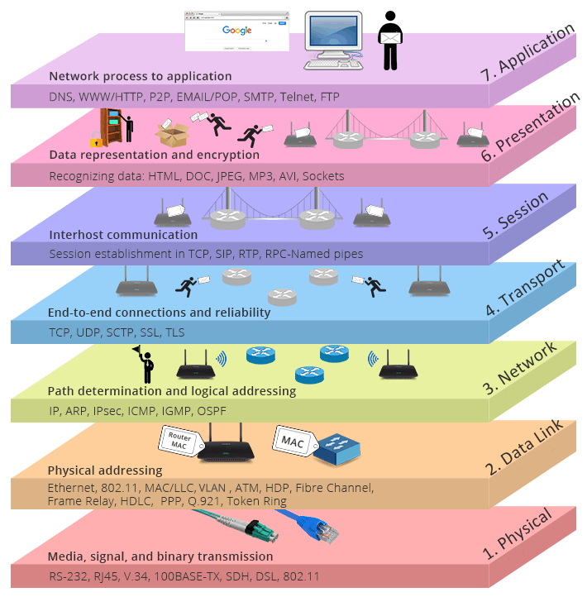

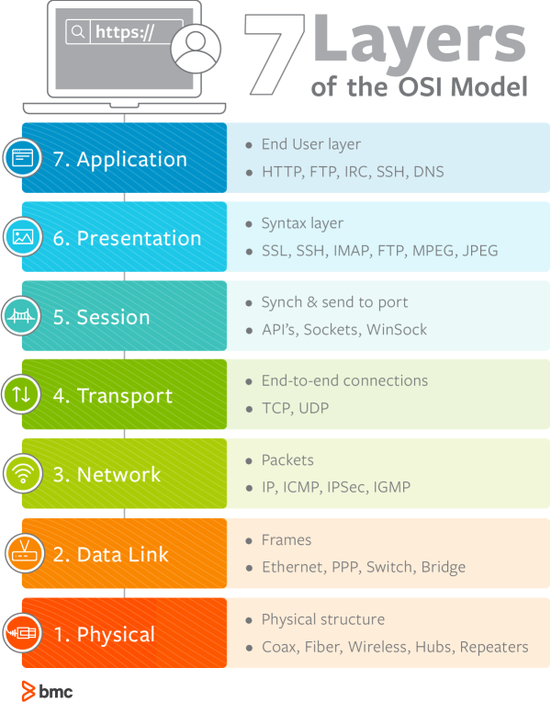

## Physical (Layer 1):

This Layer will provides the [hardware](http://www.webopedia.com/TERM/H/hardware.html) means of sending and receiving data on a carrier, including defining cables, cards and physical aspects. [Fast Ethernet](http://www.webopedia.com/TERM/F/Fast_Ethernet.html), [RS232](http://www.webopedia.com/TERM/R/RS_232C.html), and [ATM](http://www.webopedia.com/TERM/A/ATM.html) are [protocols](http://www.webopedia.com/TERM/P/protocol.html) with physical layer components.

Layer 1 Physical examples include Ethernet, FDDI, B8ZS, V.35, V.24, RJ45.

## Data Link (Layer 2):

At OSI Model, Layer 2, data packets are [encoded](http://www.webopedia.com/TERM/E/encoding.html) and decoded into bits. It furnishes protocol knowledge and management and handles errors in the physical layer, flow control and frame synchronization. The data link layer is divided into two sub layers: The Media Access Control ([MAC](http://www.webopedia.com/TERM/M/MAC_address.html)) layer and the [Logical Link Control](http://www.webopedia.com/TERM/L/Logical_Link_Control_layer.html) (LLC) layer. The MAC sub layer controls how a computer on the network gains access to the data and permission to transmit it. The LLC layer controls frame [synchronization](http://www.webopedia.com/TERM/D/data_synchronization.html), flow control and error checking.

Layer 2 Data Link examples include PPP, FDDI, ATM, IEEE 802.5/ 802.2, IEEE 802.3/802.2, HDLC, Frame Relay.

## Network (Layer 3):

Layer 3 provides [switching](http://www.webopedia.com/TERM/P/packet_switching.html) and [routing](http://www.webopedia.com/TERM/R/routing.html) technologies, creating logical paths, known as [virtual circuits](http://www.webopedia.com/TERM/V/virtual_circuit.html), for transmitting data from [node](http://www.webopedia.com/TERM/N/node.html) to node. Routing and forwarding are functions of this layer, as well as [addressing](http://www.webopedia.com/DidYouKnow/Internet/IPaddressing.asp), [internetworking](http://www.webopedia.com/TERM/I/internetworking.html), error handling, [congestion](http://www.webopedia.com/TERM/C/congestion.html) control and packet sequencing.

 Layer 3 Network examples include AppleTalk DDP, IP, IPX.

## Transport (Layer 4):

OSI Model, Layer 4, provides transparent transfer of data between end systems, or [hosts](http://www.webopedia.com/TERM/H/host.html), and is responsible for end-to-end error recovery and [flow control](http://www.webopedia.com/TERM/F/flow_control.html). It ensures complete data transfer.

 Layer 4 Transport examples include SPX, TCP, UDP.

## Session (Layer 5):

This layer establishes, manages and terminates connections between [applications](http://www.webopedia.com/TERM/A/application.html). The session layer sets up, coordinates, and terminates conversations, exchanges, and dialogues between the applications at each end. It deals with session and connection coordination.

 Layer 5 Session examples include NFS, NetBios names, RPC, SQL.

## Presentation (Layer 6):

This layer provides independence from differences in data representation (e.g., [encryption](http://www.webopedia.com/TERM/E/encryption.html)) by translating from application to network format, and vice versa. The presentation layer works to transform data into the form that the application layer can accept. This layer formats and encrypts data to be sent across a [network](http://www.webopedia.com/TERM/N/network.html), providing freedom from compatibility problems. It is sometimes called the syntax layer.

 Layer 6 Presentation examples include encryption, ASCII, EBCDIC, TIFF, GIF, PICT, JPEG, MPEG, MIDI.

## Application (Layer 7):

OSI Model, Layer 7, supports [application](http://www.webopedia.com/TERM/A/application.html) and end-user processes. Communication partners are identified, quality of service is identified, user authentication and privacy are considered, and any constraints on data[syntax](http://www.webopedia.com/TERM/S/syntax.html) are identified. Everything at this layer is application-specific. This layer provides application services for[file transfers](http://www.webopedia.com/Communications/File_Transfers/), [e-mail](http://www.webopedia.com/TERM/E/e_mail.html), and other [network](http://www.webopedia.com/TERM/N/network.html) [software](http://www.webopedia.com/TERM/S/software.html) services. [Telnet](http://www.webopedia.com/TERM/T/Telnet.html) and [FTP](http://www.webopedia.com/TERM/F/FTP.html) are applications that exist entirely in the application level. Tiered application architectures are part of this layer.

 Layer 7 Application examples include WWW browsers, NFS, SNMP, Telnet, HTTP, FTP

1. **The Main Difference Between Windows 2003 & Windows 2008?**

* 2008 is combination of vista and windows 2003r2.
* Some new services are introduced in it
* RODC one new domain controller introduced in it (Read Only Domain Controller).
* WDS (windows deployment services) instead of RIS in 2003 server
* Shadow copy for each and every folders
* boot sequence is changed
* installation is 32 bit where as 2003 it is 16 as well as 32 bit, that’s why installation of 2008 is faster.
* services are known as role in it
* Group policy editor is a separate option in ads
* The main difference between 2003 and 2008 is Virtualization, management2008 has more inbuilt components and updated third party drivers Microsoft introduces new feature with 2k8 that is Hyper-V  Windows Server 2008 introduces Hyper-V (V for Virtualization) but only on 64bit versions.

-only Domain controllers.]

**(16) The Main Difference Between Windows 2008 & Windows 2012?**

Server 2008 version had both 32 bit and 64 bit releases, however Server 2008 R2 started with migrating to completely 64 bit operating system releases for better performance and scalability, and Server 2012 completely is a 64 bit operating system. That’s where the future is heading in Microsoft Windows Server Operating systems.

**IIS 8:** Windows Server 2012 features IIS 8 which brings its latest version with features like script pre-compilation, granular process throttling, centralized certificate management, etc.

**Power Shell 3.0**: Power Shell is going to be the future of Microsoft. With Command line interfaces being less popular over the last decade, Microsoft is building up with newer versions of power shell with more advanced features and that’s where IT Professionals have to keep in mind and keep learning the new cmdlets.

**Server Core:** Server core was introduced in Windows Server 2008 as a competitor to Linux/Unix operating systems but with limited features. Microsoft is coming up with advanced features and with Server 2012 installation, it gives an option to switch to Server Core and vice-versa after the installation.

**Direct Access:** Direct Access was considered to be a replacement to VPN and was introduced with Windows Server 2008 but with Server 2012, it is much easier to use.

**Hyper-V 3.0:** Hyper-V introduces a new version 3.0 which offers an extensible virtual switch and live storage migration which is a step up from Server 2008 R2’s Quick Storage Migration to prevent downtime. It is also capable of migrating virtual machines (VMs) without shared storage.

**(17)** **What is RODC and when we will be use RODC & Advantages of RODC**

**Answer:**

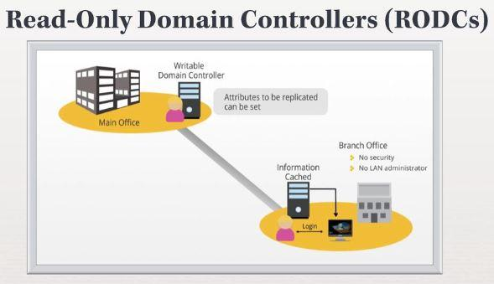

One of the new features receiving close attention in Windows 2008 is a new breed of domain controllers referred to as Read-Only Domain Controllers, also known as RODCs.   
  
Read-only domain controllers (RODCs) in Active Directory, intended for use in branch office or other scenarios where a domain controller may reside in a low physical security environment. The RODC holds a non-writeable copy of Active Directory, and redirects all write attempts to a Full Domain Controller. It replicates all accounts except sensitive ones.In RODC mode, credentials are not cached by default. Moreover, only the replication partner of the RODC needs to run Windows Server 2008. Also, local administrators can log on to the machine to perform maintenance tasks without requiring administrative rights on the domain.

This means all changes from a writable domain controller are propagated to the RODCs. As a result, the RODC receives changes, but does not partake in or perform outbound replication with other domain controllers.

**Features of RODC:**

* Read Only Active Directory Database
* Only allowed user passwords are stored on RODC
* Unidirectional Replication
* Role Separation

**Benefits of RODC:**

**Increases security for remote Domain Controllers where physical security cannot be guaranteed**

**Roles and Services Supported by RODC**

ADFS,DNS, DHCP, FRS V1, DFSR (FRS V2), Group Policy, IAS/VPN, DFS, SMS, ADSI queries, MOM

After getting to know RODC better, are you able to determine when to use RODC? Something more for you all to know and consider is that configuration of a RODC is not as easy as setting up one.The Key point to note on when you want to deploy a RODC is level of **SECURITY**.

If your remote branch office has a server room that is locked at all time and only authorize personnel is able to access it (Physically Secured), my advise is not to use RODC that will complicate your future administration. As what the Key Benefit of RODC above stated… RODC is meant for branch office which require a local DC for authentication but physical security cannot be guaranteed.

**(18) Authoritative and Non Authoritative Restoration.**

**Non-Authoritative Restoration**

Used most commonly in cases when a DC because of a hardware or software related reasons, this is the default directory services restore mode selection. In this mode, the operating system restores the domain controller’s contents from the backup. After this, the domain controller then through replication receives all directory changes that have been made since the backup from the other domain controllers in the network. 

**Authoritative Restoration**

An authoritative restore is most commonly used in cases in which a change was made within the directory that must be reversed, such as deleting an organization unit by mistake. This process restores the DC from the backup and then replicates to and overwrites all other domain controllers in the network to match the restored DC. The especially valuable thing about this is that you can choose to only make certain objects within the directory authoritative. For example, if you delete an OU by mistake you can choose to make it authoritative. This will replicate the deleted OU back to all of the other DC’s in the network and then use all of the other information from these

**Major Difference between Authoritative VS Non Authoritative:**

**Authoritative restore means , within domain updates are sent to outside domains in forest but it will never getting any updates from outside domains. (Sending is in active state but receiving is in deactive state)**

**Non Authoritative restore means Vice versa means within domain updates sending to other domains in the forest also getting updates from otherdomains within the forest.**

**(19) Windows Standard to Enterprise Upgradation plan**.

(20) **Datacenter Power Maintenance Activity Consolidation Plan?**

ANSWER:

**Please refer the below attached Power shutdown and Power ON Sequence Report for Servers.**

1. **What are different types of backup methods?**

**Answer**:

## Types of Backups:

| | * **Normal (Full) Backups** * **Incremental Backups** * **Differential Backups** * **Mirror Backups**  **Full Backups:** **Full backup** is the starting point for all other backups, and contains all the data in the folders and files that are selected to be backed up. Because **full backup** stores all files and folders, frequent full backups result in faster and simpler restore operations. Remember that when you choose other **backup types**, restore jobs may take longer.   * This approach is good when the project includes not so large amounts of data.  **Incremental Backups:** An **incremental backup** stores all files that have changed since the last **backup**. The advantage of an**incremental backup** is that it takes the least time to complete. However, during a restore operation, each**incremental backup** must be processed, which could result in a lengthy restore job.   * This approach is good when the project includes too many files to back up them all each time. It's fast and takes less time for incremental backups. Incremental backups take less disk space. It allows you to create backups frequently. However, to restore all the files, you have to restore the last full backup, and all the following incremental backups.  **Differential Backups:** A **differential backup** contains all files that have changed since the Previous **full backup**. The advantage of a**differential backup** is that it shortens restore time compared to an **incremental backup**. However, if you perform the **differential backup** too many times, the size of the **differential backup** might grow to be larger than the baseline **full backup**.   * Is intermediate between the first two approaches. It is also good when the conditions are intermediate. * Each differential backup includes all the project files changed since the last full backup. It takes less time and space than "Always Full", but more than "Full+Incremental". The good thing is that restoring is simpler than for (2) - you'll have to restore the last full backup and the last differential backup.  **Mirror Backups:** Mirror backup includes all files that have changed since the last normal (full) or mirror backup, missing files are also be deleted from the backup set. The resulting backup archive consists of either one compressed file or one folder. | | --- | |
| --- | --- |

**(2) Boot Sequence of Windows Server 2008.**

The new boot environment supports both BIOS and Unified Extended Firmware Interface (UEFI) firmware models. It uses a new data store for boot configuration data (the BCD store) that replaces Boot.ini and provides new boot applications that replace the previous Windows® loader (Ntldr.exe), including a new Windows boot manager and Windows boot loader.

1. System is powered on
2. The CMOS loads the BIOS and then runs POST
3. Looks for the MBR on the bootable device
4. Through the MBR the boot sector is located and the BOOTMGR is loaded
5. BOOTMGR looks for active partition
6. BOOTMGR reads the BCD file from the \boot directory on the active partition
7. The BCD (boot configuration database) contains various configuration parameters( this information was previously stored in the boot.ini)
8. BOOTMGR transfer control to the Windows Loader (winload.exe) or winresume.exe in case the system was hibernated.
9. Winloader loads drivers that are set to start at boot and then transfers the control to the windows kernel.

[**Active Directory Interview Question & Answers**](http://forums.techhowknow.com/viewtopic.php?f=6&t=4#p4)

**1. What is Global Catalog Server?**

Global Catalog server is the server which keeps the stores the details of each object created in the forest. Global Catalog is the master searchable index to all objects in forest  
  
**2. Can GC Server and Infrastructure place in single server? If not explain why?**

No, As Infrastructure master does the same job as the GC. It does not work together.  
  
**3. What is the size of log file which created before updating into ntds.dit and the total number of files?**

**Three Log files Names:**

* Edb.log
* Res1.log
* Res2.log
* Each initially 10 MB  
    
  **4. What does SYSVOL contains?**

SysVol Folder contains the public information of the domain &amp; The information for replication  
Ex: Group policy object &amp; scripts can be found in this directory.  
  
**5. Which is service in your windows is responsible for replication of Domain controller to another domain controller.**

KCC generates the replication topology.  
Use SMTP / RPC to replicate changes.  
  
**6. How data will travel between sites in ADS replication?**

As determined in the site connectors  
  
**7. What is the port number for SMTP, Kerberos, LDAP, and GC Server?**  
 SMTP 25, Kerberos 88, GC 3268, LDAP 389

**8. What Intrasite and Intersite Replication?**

Intrasite is the replication within the same site &amp; intersite the replication between sites.

**9. What is lost & found folder in ADS?**

It’s the folder where you can find the objects missed due to conflict. Ex: you created a user in OU which is deleted in other DC &amp; when replication happed ADS didn’t find the OU then it will put that in Lost &amp; Found Folder.  
  
**10. What is Garbage collection?**

Garbage collection is the process of the online defragmentation of active directory. It happens every 12 Hours.  
  
**11. What System State data contains?**

* Contains Startup files,
* Registry
* Com + Registration Database
* Memory Page file
* System files
* AD information
* Cluster Service information
* SYSVOL Folder

**12. How do you restore a particular OU which got deleted by accident?**

Go authoritative restore  
  
**13. What is IPSec Policy?**

IPSec provides secure gateway-to-gateway connections across outsourced private wide area network (WAN) or Internet-based connections using L2TP/IPSec tunnels or pure IPSec tunnel mode. IPSec Policy can be deployed via Group policy to the Windows Domain controllers 7 Servers.  
  
**14. What are different types of Group Policy?**

* Local Policy.
* Site Policy.
* Domain Policy.
* OU Policy.

**15. What is the order of applying Group Policy?**

* Local Policy.
* Site Policy.
* Domain Policy.
* OU Policy.

**16. What are the new features in Windows 2003 related to ADS, Replication, and Trust?**

ADS: Can more than 5000 users in the groups  
  
**17. How to edit the Schema in ADS?**

ADSI Edit  
  
**18. What is Domain Local, Global Group, Universal group?**

**Domain Local** – Only Users with in Domain

**Global groups** are used to grant permissions to objects in any domain in the domain tree or forest. Members of global groups can include only accounts and groups from the domain in which they are defined.

**Universal groups** are used to grant permissions on a wide scale throughout a domain tree or forest. Members of global groups include accounts and groups from any domain in the domain tree or forest.  
  
**19. Diff between Global & Universal group?**

Check the answer above.  
  
**20. What are the different types of Terminal Services?**

User Mode &amp; Application Mode  
  
**21. What does mean by root DNS servers?**

Public DNS servers Hosted in the Internet which registers the DNS  
  
**22. What are the different records in DNS?**

* **A –** Address record
* **MX –** Mail Server Record
* **NS –** Name Server
* **CNAME–** Canonical name / Alias
* **SOA –** Start of authority

**23. What is a SOA record?**

Start of authority – authorized DNS in the domain

**24. How does the down-level clients register it names with DNS server?**

Enable the WINS integration with DNS.

**25. What is RsOP?**

RsOP is the resultant set of policy applied on the object (Group Policy)  
  
**26. What is default lease period for DHCP Server?**

8 days Default  
  
**27. What is the process of DHCP clients for getting the ip address?**

Discover – Order – Receive - Acknowledge  
  
**28. What is multicast?**

Multicast scopes enable you to lease Class D IP addresses to clients for participation in multicast transmissions, such as streaming video and audio transmissions.  
  
**29. What is superscope?**

Superscope enables you to group several standard DHCP scopes into a single administrative group without causing any service disruption to network clients.  
  
**30. What is the System Startup process? [OPTIONAL]**

Windows 2K boot process on Intel architecture.  
  
1. Power-On Self Tests (POST) is run.  
2. The boot device is found, the Master Boot Record (MBR) is loaded into memory, and its program is run.  
3. The active partition is located, and the boot sector is loaded.  
4. The Windows 2000 loader (NTLDR) is then loaded.  
  
**The boot sequence executes the following steps:**  
1. The Windows 2000 loader switches the processor to the 32-bit flat memory model.  
2. The Windows 2000 loader starts a mini-file system.  
3. The Windows 2000 loader reads the BOOT.INI file and displays the operating system selections (boot loader menu).  
4. The Windows 2000 loader loads the operating system selected by the user. If Windows 2000 is selected, NTLDR runs NTDETECT.COM. For other operating systems, NTLDR loads BOOTSECT.DOS and gives it control.  
5. NTDETECT.COM scans the hardware installed in the computer, and reports the list to NTLDR for inclusion in the Registry under the HKEY_LOCAL_MACHINE_HARDWARE hive.  
6. NTLDR then loads the NTOSKRNL.EXE, and gives it the hardware information collected by NTDETECT.COM. Windows NT enters the Windows load phases.

**31. What is WINS hybrid & mixed mode? [OPTIONAL]**

Systems that are configured to use WINS are normally configured as a hybrid (Hnode) client, meaning they attempt to resolve NetBIOS names via a WINS server and then try a broadcast (B-node) if WINS is unsuccessful. Most systems can be configured to resolve NetBIOS names in one of four modes:  
  
**Broadcast (B-node)**—Clients use a broadcast only to resolve names. An enhanced Bnode setting has the client use an LMHOST file as well. The hex value for this setting is 0x1.

**Peer-to-Peer (P-node)**—Clients use WINS only to resolve names. The hex value for this setting is 0x2.

**Mixed (M-node)**—Clients first use a broadcast in an attempt to resolve NetBIOS names. If this fails, they attempt the resolution via the WINS server. The hex value for this setting is 0x4.

**Hybrid (H-node)**—Clients first use the WINS service in an attempt to resolve

**NetBIOS names**. If this fails, they attempt the resolution via broadcast. The hex value for this setting 0x8.  
  
**32. What is Disk Quota?**

Disk Quota is the specifying the limits of usage on the disks.  
  
**33. What is different Editions of Windows 2003 server?**

i) Standard Edition  
ii) Web Edition  
iii) Enterprise Edition  
iv) Datacenter Edition  
  
**34) What is active directory?**

Active Directory is a Centralized database, which can manage objects like Users,Computers,OU,Printers etc.  
  
**35)What is the active directory database name and where it is located?**

Name :NTDS.Dit located in c:\windows\ntds\  
  
**36)What is the expansion of .Dit ? Scalable size of NTDS in 2k3?**

Dit – Directory Information Tree. It is scalable up to 70 TB.  
  
**37) What is schema in AD?**

The Active Directory schema defines objects that can be stored in Active Directory. The schema is a list of definitions that determines the kinds of objects and the types of information about those objects that can be stored in Active Directory. Because the schema definitions themselves are stored as objects, they can be administered in the same manner as the rest of the objects in Active Directory. Normally called schema object or metadata.  
  
**38) Structure of AD ?**

**1) Physical structures:**  
Sites, Domain Controllers

**2) Logical structures:**  
Forest, Tree, Domain, OU, object  
  
**39) What are the domain functional levels in 2k3?**

i)Mixed mode  
ii)Native mode  
iii)Interim mode.  
  
**40) What is Global catalog and GC server?**

The global catalog is the central repository of information about objects in a tree or forest. By default, a global catalog is created automatically on the initial domain controller in the first domain in the forest. A domain controller that holds a copy of the global catalog is called a global catalog server.  
  
**41) What are the functions of GC?**

A) It enables a user to log on to a network by providing universal group membership information to a domain controller when a logon process is initiated.

B) It enables finding directory information regardless of which domain in the forest actually contains the data.  
  
**42) What is the active directory database engine name?**

ESE (Extensible Storage Engine)  
  
**43) What are the partitions available in AD?**

i) Schema partition  
ii) Configuration Partition  
iii) Domain Partition  
iv)Application Partition  
  
**44) What are the two types of replications?**

Inter-site (Site to site) and Intra-site (With in site) replications.

**45) What is KCC? What is the function of the KCC?**

The KCC is a built-in process that runs on all domain controllers. The KCC configures connection objects between domain controllers. Within a site, each KCC generates its own connections. For replication between sites, a single KCC per site generates all connections between sites.  
  
**46) What is the two trust protocols 2k3 using?**

Kerberos V5 and NTLM  
  
**47) What are the trust relations available in 2k3?**

Tree-Root , Parent- Child , Shortcut, Realm, Forest trust , External trust  
  
**48)What is the hierarchy of applying Gpo in 2k3?**

It is applied from parent level to child level in AD.  
i) Local GPO  
ii) GPOs linked to sites  
iii)GPOs linked to domains  
iv)GPOs linked to OUs  
  
**49) What are the protocols used on replication?**

RPC over IP (Used for synchronies transfer) , SMTP over IP (Asynchronies transfer)  
  
**50) What is the default time delay on replication?**

Intra site – 15 min ( KCC automatically create the topology for Replication)  
Inter-site – 1 hrs.  
Security related changes replicated immediately across sites.  
  
**51) What Different tables available in NTDS database?**

i) Schema table  
Ii) Link Table  
iii) Data table  
iv) Configuration Table  
  
**52) Where is the FRS logs stored in and what is the database engine name?**

C:\windows\ntfrs\jet\log. The engine used is jet database engine. Ntfrs.jdb.  
  
**53) What is tombstone object in AD? What is its life time?**

Any objects deleted from Active directory will not removed from Database immediately. That object is called tombstone object. The default life time for that object is 60 days. For win 2k3 SP1 180 days.

**54) What are the required components of Windows Server 2003 for installing Exchange 2003?**

ASP.NET, SMTP, NNTP, W3SVC  
  
**55) What must be done to an AD forest before Exchange can be deployed?**

Setup/forestprep  
  
**56) What 3 types of domain controller does Exchange access?**

Normal Domain Controller, Global Catalog, Configuration Domain Controller  
  
**57) What connector type would you use to connect to the Internet, and what are the two methods of sending mail over that connector?**

SMTP Connector: Forward to smart host or use DNS to route to each address   
  
**58) How would you optimise Exchange 2003 memory usage on a Windows Server 2003 server with more than 1Gb of memory?**

Add /3Gb switch to boot.ini  
  
  
**59) What are the standard port numbers for SMTP, POP3, IMAP4, RPC, LDAP and Global Catalog?**

SMTP – 25, POP3 – 110, IMAP4 – 143, RPC – 135, LDAP – 389, Global Catalog - 3268  
  
  
**60) What is the maximum amount of databases that can be hosted on Exchange 2003 Enterprise?**

20 databases.4 SGs x 5 DBs.

**VIRTUALIZATION INTERVIEW QUESTIONS AND ANSWERS**

**VIRTUAL MACHINE**

1. **Virtual Machine & vCenter Features(snapshot,clone,template,ft,ha,drs) backend process?**

Answer:-

**Snapshot**:- Pre- Reserved state of the virtual machine . Recommended during Minor changes of VM.

Snapshot to Snapshot communication will happen by Metadata Links and once you taken the snapshot the base VM is in Read Mode and Snapshot is in Write mode because of that changes will saved only on Snapshot disk (Delta.vmdk). Once committed / Reverted snapshot then Base VM will be Read & Write access.

**Clone**:- Duplicate copy of VM. Recommended during Major changes of VM.

We need to run the sysprep file after done the clone before power on the clone virtual machine because Same DID and SID will create so we should run Sysprep file to create new ID’s

**Criticality:** If we are not running the sysprep file we will experience duplicate ip and system name in network which is big impact to production down

**Template**:- Master Copy of Virtual Machine with help of template will deploy N number of VM’s. Regarding golden template basically I will use golden template mechanism to my daily build vm’s. Golden template means customized virtual machine with all system and business requirements(Guest OS , local firewall turned off ,enable Hot Add feature, Page file Configuration, set the CPU and Memory limitations, install antivirus, install monitoring software, set the ip address via dhcp and vm resources should be standard manner etc)

**FT**:- Fault Tolerance for VM 100% availability and 0% downtime. FT will work on vLockStep Technology.

When we enable FT the FT VM will create secondary VM in another ESXi Host and both have replication in continue manner.

**HA**:- High Availability Cluster / Failover Over Cluster. FDM Technique is the backend of HA.

**DRS**:- Load Balancing Cluster, will Maintain Memory and CPU Loads across cluster. (No Backend Process)

1. **What is Virtualization and What is VM & VM Files?**

* Virtualization is a Technology, which can transform Hardware into Software with help of Hypervisor (ESXi).
* Virtual Machine is a computer which looks like a Physical Machine but it is software Generated Machine. It contains discrete set of files like

1. Virtual Machine Configuration file --- vmname.vmx.
2. Virtual Machine Disk file --- vmname.vmdk.
3. Virtual Machine Bios File --- vmname.nvram.
4. Virtual Machine Log file --- vmname.log.
5. Virtual Machine Swap file --- vmname.vswp.
6. Virtual Machine Snapshot List --- vmname.vmsd.
7. Virtual Machine Snapshot Main File --- delta.vmdk
8. Virtual Machine Snapshot Data --- Vmname.vmsn
9. Virtual Machine Extend Config --- Vmname.Vmxf
10. Virtual Machine Template --- Vmname.Vmtx.
11. Virtual Machine Actual Hard disk File --- Vmname.Flat.vmdk.
12. **How to register and un-register the VM?**

ANSWER:

* Remove the VM from Inventory is called un-registration
* Go to the VM Datastore (Browse Datastore) then select the VM Folder and Right Click the .VMX file and click on Add Inventory its called VM Registration.

1. **What is snapshot and file extension and how you will take snapshot?**

ANSWER:

* Snapshot is a VC Feature and it’s pre-reserved state of the virtual machine.
* In terms of VM backup we can use Snapshot and snapshot main extension file is DELTA.VMDK
* Basically we will take VM snapshot during minor changes of Virtual Machine.
* Which will help us during Guest OS patching (Example: Microsoft security patching), VM Reconfiguration like Upgrading Memory/CPU/NIC/VMDK , Application minor patching and any VM Schedule maintenance reboot.
* Snapshot Manager can manage All Snapshots for the specific Virtual Machine.

**Process of Create Snapshot**:-

Right Click VM🡪Click on Take Snapshot🡪Provide snapshot name and provide description🡪OK

**Commit Snapshot / Delete Snapshot:-**

Right Click VM🡪Click on Snapshot Manager🡪Select Top Snapshot🡪Click on Delete / Delete All

* When we need to revert back the same state of VM without any changes in VM it is very useful.
* Snapshot is used for UPDATES & CLONE Is used for UPGRADATION**.**
* **Revert Snapshot**:- After performed the above said operations if the changes are not successful then we need to remove all installed patches/ application changes and need to revert back the Virtual machine to previous state is called Revert / Goto.

Right Click VM--> Select Revert (or) Go to Snapshot Manager--> Select Snapshot and Click on GOTO

1. **What is Clone and how you will take clone?**

ANSWER:

* It is one of the VC feature.
* Clone is a duplicate copy of virtual machine.
* It is used in Testing & Development Environment.
* Basically we will take Clone for Major changes like OS Upgradation, Application Upgradation& Stage Environments for temporary purpose.
* Right Click the VM and select Clone🡪Provide VM Name🡪Choose Datastore🡪Finish. (Here we will uncheck the NIC)
* Once done the Clone then power On the VM and login with local administrator account then change Guest host name and IP Addres then connect the NIC and handed over to the customer.

1. **What is Template and How to deploy Virtual Machine from Template.?**

ANSWER:

* It is one of the virtual center feature.
* Template is Master copy of the Virtual Machine.
* With help of Template we can deploy N number of Virtual Machines
* Basically I can Create Golden Templates for each and every department such as
* Windows Server 2003,2008,2008 R2,2008 R2 Enterprise SP2, Citrix Golden Template, Exchange Golden Template, AD Golden Template, Database Golden Template.

Once done the below Customizations on Golden Template from my end then I can handed over to application team to install respective applications; post application installation I can convert the VM as Golden Template Before Convert to Template I can perform the Hardening Tasks.

1) Enable the Hot Add Feature

2) Configured vNIC adapter as VMXNET3

3) Set the resource reservation as UnLimit

4) Guest OS System preparation

5) Local Admin password set

6) Configured Page File as Microsoft recommendation (1.5 Times)

7) Set the VMDK size as 80 GB ( Guest OS + Page File)

8) Reserved it in Workgroup

9) Kept the NIC card in DHCP Pool and added DNS suffixes as requested by Mike.

10) Installed Microsoft Patches till dated.

11) Configured Timezone& Local firewall as per WMT recommendation.

12) The Template name is “Server 2008 R2 Golden Template”. (Inside Guest OS name is Server

Post Converting VM as Template then I can deploy a virtual machine and reconfigure the virtual machine as per the Build Form. Once Power ON the new deployed VM then I can run SYSPREP File to avoid SID + DID duplications on Virtual Machine.

1. **What is RDM & Types?**

ANSWER:

**RAW DEVICE MAPPING (RDM).**

1. A Raw Device Mapping is a file stored in a VMFS volume.
2. Raw Device Mapping allows you to store virtual machine data directly on a LUN.
3. The Mapping file is stored on a VMware vSphere VMFS data store .
4. The RDM file Name is “VMname.rdm.vmdk”.

**Benefit of RDM:**

When we need more hard disk size like more than 600 GB for the business requirement such as Exchange, Database, Domain Controllers and File Servers then we can proceed on RDM disk instead of VMDK; which will help to improve I/O operations performance and also one of the best recommendations for production confirmed by VMware.

**Types of Raw Device Mapping:**

1. **Virtual compatibility mode**:-

This will mapped to VMFS volumes and VMKernel will send Read and Write to VM so full virtualization features will work like Vmotion,Snapshot,clone,etc...

1. **Physical compatibility mode**:-

In this mode VMKernal passes all commands to Physical SCSI so there is no VMFS reference then no Vmware features can support in this mode.

Physical mode also allows virtual-to-physical clustering for cost-effective high availability

**Limitations of physical compatibility mode :**

1.VMware snapshots are not allowed

2.VCB (VMware consolidated backup) support is not possible, because VCB requires VMware snapshots

3.Cloning of VMs that use physical mode RDMs is not possible

4.Converting VMs into templates that use physical mode RDMs is not possible

5.Migration of VMs with physical mode RDMs if the migration involves copying the disk is not possible.

6.NoVMotion with physical mode RDMs

**RDM:-** (Raw Device Mapping)

**SAN-->LUN 1--> DIRECT ASSIGN TO VM-->RDM.**

**HOW TO ADD RDM DISK TO VM:-**

1. Right click the VM

2. Go to Edit Settings.

3. Select Hardware Tab

4. Click on Add

5. Select Hard Disk-->Click on Next

6. Here Select option Raw Device Mapping instead of New Disk

7. Click on Next and Select new Provisioned LUN (Please refer LUN ID).

8. Click on Next and Click on Finish.

1. **What is Vmotion& Svmotion and also conditions?**

ANSWER:

**VMOTION**

* It is one of the VC feature.
* Moving running Virtual Machines from one ESX Host to another ESX Host without down time is called VMotion.
* VMotion works by Changes in Memory BitMap.

**WHY WE SHOULD GO FOR VMOTION**

1. **HOST MAINTENANCE PURPOSE:**

* While Updating ESX / ESXi Host Updates.
* While increasing Service Console Memory up to 800 MB in ESX 3.5
* While adding any Hardware like: Memory, CPU, DISK and NIC.

In the above all conditions ESX Host Reboot is required, so we have to Place ESX / ESXi Host into Maintenance Mode.

1. **CONTINUOUS VM OPERATIONS:**

Insufficient resources in our VM’s in that Scenario for VM continuous operations purpose better to move VM’s from one ESX / ESXi Host to another ESX / ESXi Host.

1. **BETTER HARDWARE UTILIZATION:**

Insufficient resources in our ESX Host in that Scenario better to move VM’s from One Host to another Host.

**SVMOTION**

MOVING RUNNING VIRTUAL MACHINE DISK FILES FROM ONE SHARED STORAGE (Datastore) TO ANOTHER SHARED STORAGE (Datastore) IS CALLED SVMOTION.

**WHILE MOVING VM’s FROM ONE HOST TO ANOTHER HOST& DATASTORE -DATASTORE WE HAVE TO MEET SOME CONDITIONS.**

1. CPU COMPATIBILTY (CPU should be same family either INTEL (or) AMD).
2. STORAGE SHOULD BE COMMON (or) SHARED STORAGE.
3. RESOURCES SHOULD BE AVAILABLE IN DESTINATION HOST.
4. PHYSICAL N/W SHOULD BE SAME NETWORK.
5. CREATE VMKERNEL PORT GROUP IN BOTH SOURCE & DESTINATION HOST’s.
6. NO ACCESS OF MOUNTABLE DEVICES EX: CD, FLOPPY.
7. NO PERMISSION TO VMX FILE.
8. **Esxi Polices / Multi pathing Policies 5.5?**
9. Round Robin (2) VMware Fixed (3) MRU (Most Recently Used)
10. **ESX 3.5 storage policies or Multipathing information**

Ans:

(1) Fixed (2) Most Recently Used (3) Round Robin (Experimental) & **Fixed path with Array Preference**

1. **vNUMA mode?----V.V.IMP**

Ans:

vNUMA (virtual non-uniform memory Architecture) is a memory-access optimization method for VMware virtual machines ([VMs](http://searchservervirtualization.techtarget.com/definition/virtual-machine)) that helps prevent memory-bandwidth [bottlenecks](http://searchenterprisewan.techtarget.com/definition/bottleneck).

vNUMA by default enabled on VM , Once the Hot-Add feature is enabled on a VM, vNUMA is automatically disabled.o

vNUMA is enabled by default on all virtual machines that have 8 or more vCPUs configured, as generally this will improve performance on these bigger VMs.

We have to understand Uniform Memory Architecture (UMA) & Non Uniform Memory Architecture (NUMA). Before vNUMA.

Numa basically will help improve virtual machine Memory and CPU performance.

1. **Peristantant & Non Persistant?**

**Persistent**: Saving the VMDK data permanently on disk, basically persistent is default for VM.

**Non Persistent** : Temporary data saving in Virtual Machine . If you define VMDK as non persistent once you powered off the VM and Revert the snapshot shot you VMDK data will lost.

1. **Linked clone?**

A **linked clone** is a copy of a virtual machine (**VM**) that shares virtual disks with its parent **VM**. The term is most often associated with **VMware**.

1. **vAPP& virtual appliance V.V.IMP**

A **virtual appliance** can be deployed as a VM or a subset of a **virtual machine** running on virtualization technology, such as **VMware** Workstation. Deploying an application as a **virtual appliance** can eliminate problems with installation and configuration, such as software or driver compatibility issues.

**Definition 2:**

A VMware vApp is a collection of pre-configured virtual machines ([VMs](http://searchservervirtualization.techtarget.com/definition/virtual-machine)) that combine applications with the operating systems that they require.

vAPP will help us in configuration of OVF Templates, which are free defined.

1. **How do you troubleshoot if vmdk file is corrupted?**

Ans:

With Help of Flat.vmdk, which we can able to view by connecting Host by SSH (Putty).

1. **What is NAA id?**

Ans:

Network Addressed Authority, which is unique at ESXi Level and SAN Level.

In LUN WWN number the last 4 Digit called as NAA number.

1. **Difference between extend and expand?**

Ans:

**EXPAND**: Best Practice use Expand option for Datastore Increase from 2 TB to 5 TB upto 64 TB.

**EXTEND** : Best Practice extend used for increase VMDK at virtual machine level and increase unallocated space at Guest OS Disk Management Level.

1. **Difference of covert to template and clone to template**

**Convert To Template:**

The entire virtual will convert to Template and .vmtx will create in Datastore Virtual machine Folder

**Clone To Template**:

Duplicate will create from VM and which will convert as Template still your base VM remain same.

1. **How to monitor the performance of vm?**

**Answer**:

vCenter VM performance TAB otherwise will create performance counter in Guest OS level With Performon Command.

1. **How to calculate snapshot consumed space?**

We can able to see the snapshot consumed space in Datastore VM Folder.

SNAPSHOT SIZE IS= VMDK FREE SPACE-DELTA.VMDK

1. **What will be the impact on environment if Vcenter is offline?**

VMOTION won’t work because vmotion mechanism will work on DRS and DRS isvcenter feature.

WhenvCenter is down vMotion,SvMotion& DRS wont work. HA & FT will work.

1. **What are different types of licenses in Vmware?**
2. Standard 2. Enterprise 3. Enterprise Plus
3. **NIC teaming?**

Combination of more than one uplink is called NIC team. NIC teaming will help us network traffic Load balancing. NIC teaming will configure in vSwitches.

1. **What is CPU affinity?**

Based on CPU condition the Virtual Machines will stay on Singel ESXi Host. Like you can assign each virtual machine to processors in the specified affinity set.

CPU Ready time will act major factor in CPU Affinity Role.

1. **What is host profile purpose of Host profile?**

Want to take ESXi Configuration Backup will take host profile. Right on ESXi and select Host profile

1. **How do you define syslog path**

**While installing VC we will define the Syslog Path.**

1. **What are the Logs we have in VMware?**

Ans:

**ROOT LOGS:**

* Vmkwarning
* Vmkernal logs (H/w & Storage)
* Vmksummary
* Vpxa Logs
* Hostd Logs
* FDM Logs
* Message Logs

1. **What is data depulication?**

Ans:

In computing, **data deduplication** is a specialized **data** compression technique for eliminating duplicate copies of repeating **data**. Related and somewhat synonymous terms are intelligent (**data**) compression and single-instance (**data**) storage.

1. **What is HOSTD?**

Ans**:**

* HOSTD is ESXi agent and its main communication condent to the Host.
* If ESXi is not behaving normal in VC then we have to run the Agent with help of SSH
* In ESX 3.5 we can use **#service mgmt-vmware start**
* In ESXi 5.0/5.1 & 5.5 we can use  **#/etc/init.d/hostd restart**

1. **What is VPXA and VPXD?**

Ans**:**

* VPXA is a vCenter agent and also it will act as interface between ESXi and vCenter.
* Whenever you restart HOSTD then have to restart VPXA as recommendation.
* To restart VPXA in ESX 3.5 will use **#service vmware-vpxa start/restart.**
* To restart VPXA in ESXi 5.0/5.1 & 5.5 then will use **#/etc/init.d/vpxa restart.**
* VPXD is vCenter server service to login into the vCenter with help of vSphere Client.

1. **What is Maintenance Mode?**

Ans:

To upgrade ESXi and to upgrade hardware we can use Maintenance mode for Host.

1. **what are 2 accounts have bydefault admin right in VMWare?**

Ans:

1. VPXA
2. ROOT
3. **What is Lockdown Mode?**

Ans:

Lockdown mode we can to restrict remote users by accessing the Host individually instead of VC.

1. **What is Linked Mode?**

Ans:

With help of Linked mode we can perform VM operation between 2 datacenters and 2 vCenters.

1. **when my host upgradation is failed at 14% , can you justify what could be the reason.**

Ans:

**Cause1** : Due to HA Cluster configuration. **Solution: Need to Disable the HA Cluster.**

**Cause2**: Due to External Firewall Rules. **Solution: Need to Reconfigure the Rules.**

1. **I have 2 host cluster and enabled FT for VM1, if VM1 is down then what will happen to my FT secondary VM.**

Ans:

The secondary VM will be also powered off.

1. **I am unable to keep my ESXi host in Maintenance Mode; what could be reasons?**

Ans:

Reasons: (1) VMDK Locked (2) VM Contains Physical RDM (3) VM Contain Nested Snapshots.

1. **What is Web Client?**

Ans:

Web Client is Centralized client to manage multiple vCenters in single place for daily operations.

The vSphere Web Client enables you to connect to a vCenter Server system to manage an ESXi host through a browser

1. **In 5 node cluster ,can I migrate VM from Intel 2.00 GHz processor to 2.80 GHz?**

Ans:

You may be facing some challenges during migration but we can fix this by enabling EVC (Enhanced VMotionCondition ) in Cluster for Intel CPU.

1. **Can you migrate (VMOTION & SVMOTION) the snapshot VM from one esxi to another esxi?**

Ans:

YES from ESXi 5.0 hypervisors. NO before ESXi 5.0 means ESX 3.5,4.0,4.1&ESXi 4.0,4.1.

1. **Types of Memory Metrics in Virtual Machine**

ANSWER:

Example: 4 GB Memory Configured for VM.

1. **Active Memory**:-

Active Guest Memory is the amount of memory that it has been actively used by the virtual machine.

1. **Ballooned Memory**:-

The Balloon memory is the amount of guest physical memory that is currently reclaimed through the balloon driver (vmmemctl). This is carried out by one of the Memory management technique of ESX server named Memory Ballooning.

1. **Unaccessed Memory**:-

Unaccessed memory is the  current amount of memory not being accessed by the Virtual machine (free memory for the guest)

1. **Shared Memory**:-

Shared Guest Memory is the amount of memory which is shared through the TPS (Transparent Page sharing) one of the memory management Technique of ESX server.This value also includes the memory shared with other Virtual Machines and  shared within the Virtual Machine.

1. **Private Memory**:-

Private memory is the amount of memory that is physically backed by the Host. Private memory is calculated using the below formula

Private memory = VM Allocated Memory  –Unaccessed Memory – Shared Memory

Private Memory = 4 GB – 84.00 MB – 2.01 GB

1. **Swapped Memory**:-

Swapped Memory is the amount of guest Physical memory swapped out to the Virtual Machine’s swap device by the ESX kernel (VMkernel). This value refers to the VMkernel swapping not the Guest operating system swapping activity.

1. **Compressed Memory**:-

Compressed memory is the amount of virtual machine memory which is compressed by the VMkernel. This value should also be zero because memory compression has a performance impact. Memory compression is enabled by default. You can use the Advanced Settings dialog box in the vSphere Client to enable or disable memory compression for a host.

1. **What are Memory Management Techniques?**

ESXi uses several innovative techniques to reclaim virtual machine memory, which are:

* **Transparent page sharing** (TPS):—Reclaims memory by removing redundant pages with identical content;
* **Ballooning:**—Reclaims memory by artificially increasing the memory pressure inside the guest;
* **Hypervisor swapping:**—Reclaims memory by having ESXi directly swap out the virtual machine’s memory;
* **Memory compression:**—Reclaims memory by compressing the pages that need to be swapped out.

**Transparent page sharing (tps):**

Running multiple virtual machines on a single piece of hardware results in identical sets of memory pages. The amount of identical pages is influenced by the number of virtual machines and the (lack of) variation of operating systems. The identical memory pages enable VMware to implement memory sharing across virtual machines. Page sharing enables the hypervisor to reclaim redundant page copies and keep only one copy, which is shared by multiple virtual machines in the host physical memory. This results in a much lower host memory consumption and a high level of memory over commitment.

TPS is a default ESXi feature which runs regardless of the amount of used physical memory. TPS is turned on by default, you can only disable it by modifying the ESXi advanced settings but I would strongly advise you not to do that.  TPS can save you up to 70% (VDI environments with many identical operation systems), space which you can use to increase your consolidation ratio.

TPS is a memory management technique which is transparent for the virtual machine and it includes no performance penalty.

**Ballooning:**

Ballooning is a completely different memory management technique compared to TPS. Ballooning is used to reclaim memory from virtual machines in case of idle state and provide the same to ESXi Host whenever memory shortage to provide other virtual machines.

**Memory compression:**

Memory compression moves memory pages to a separate cache which is located in the host’s main memory. ESXi determines if a page can be compressed by checking the compression ratio for the page. Memory compression occurs when the page’s compression ratio is greater than 50%. Otherwise, memory compression has no added value and the page is swapped out. Only pages that would otherwise be swapped out to disk are chosen as candidates for memory compression.

Memory compression only occurs when there’s a host memory shortage and ballooning has not achieved the desired effect. ESXi will not proactively compress memory pages when host memory is undercommitted.

Memory compression is turned on by default, you can only disable it by modifying the ESXi advanced settings but I would strongly advise you not to do that.

**Swapping:**

When transparent page sharing, ballooning and memory compression do not have the desired effect, ESXi uses it’s last resort, hypervisor swapping. Hypervisor swapping moves the a guest’s memory pages to a virtual machine based swap file (.vswp), which frees host physical memory for other virtual machines.

Both page sharing and ballooning take time to reclaim memory. The page-sharing speed depends on the page scan rate and the sharing opportunity. Ballooning speed relies on the guest operating system’s response time for memory allocation. Hypervisor swapping is a guaranteed technique to reclaim a specific amount of memory within a specific amount of time. However, hypervisor swapping is used as a last resort to reclaim memory from the virtual machine because it has a huge performance impact.

The figure below shows how the host free memory state is reported in ESXTOP.

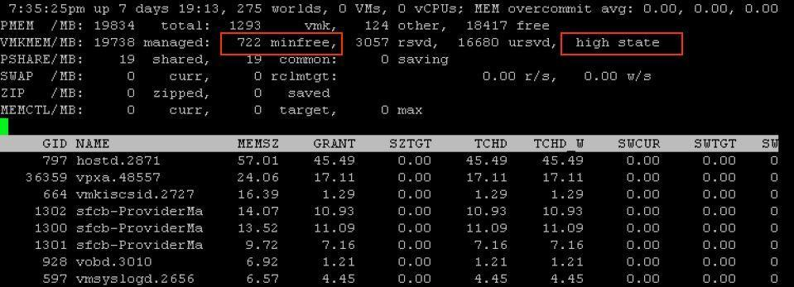

In certain scenarios, host memory reclamation happens regardless of the current host free memory state. For example, even if host free memory is in the high state, memory reclamation is still mandatory when a virtual machine’s memory usage exceeds its specified memory limit. If this happens, the hypervisor will employ ballooning and, if necessary, swapping and memory compression to reclaim memory from the virtual machine until the virtual machine’s host memory usage falls back to its specified limit.

1. **System drive & application drive expansion?**

ANSWER:

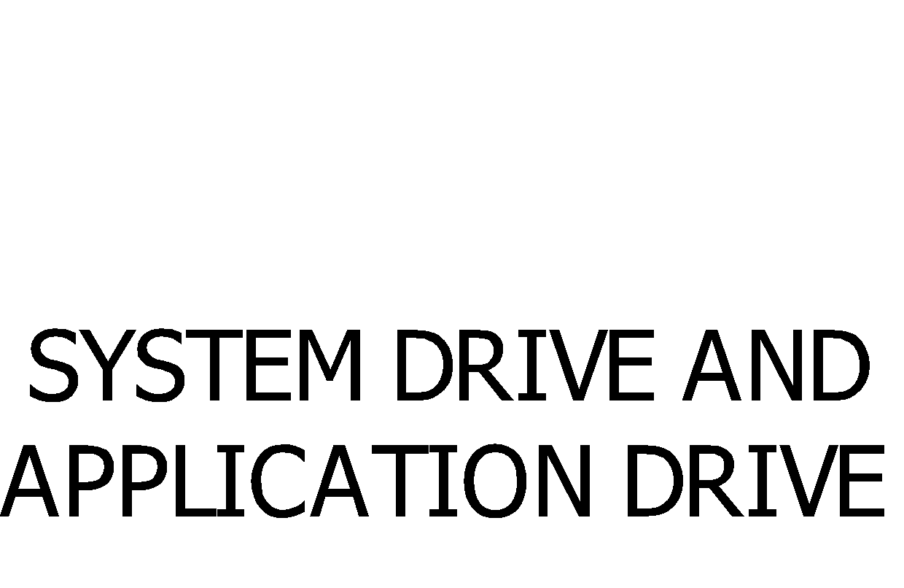

1. **Online examination questions?**

ANSWER:



1. **P2v conversion concept sop. (pre-requisites, implementation & post conversion)**

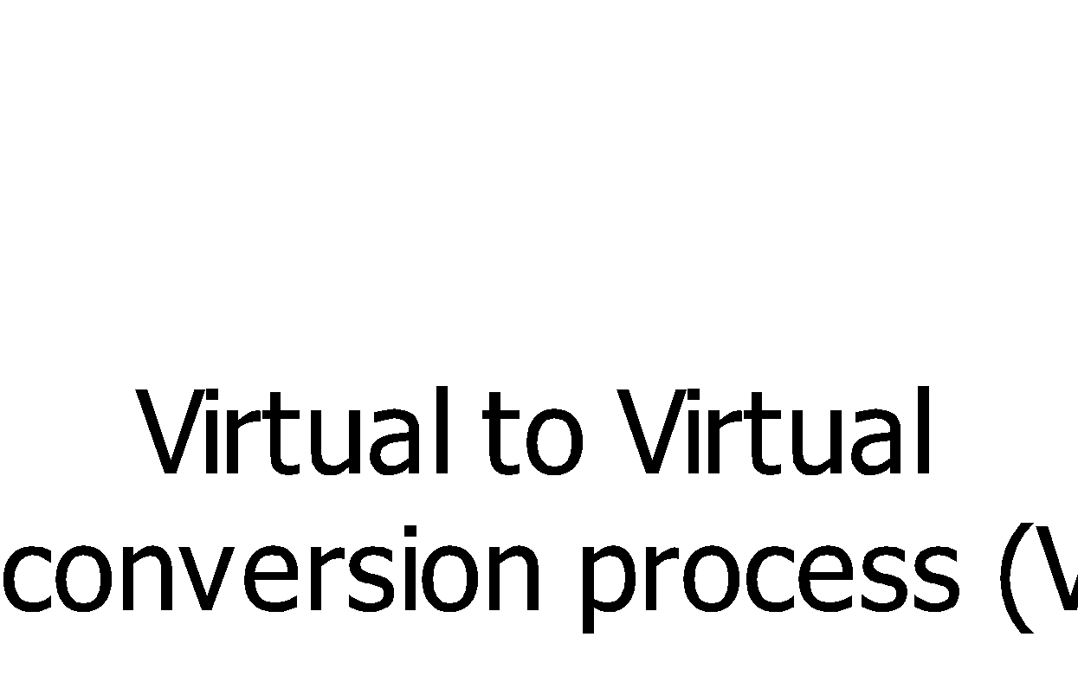

# What's the difference between a thick and eager zeroed thick?

The third type of disk provisioning in ESX—eager zeroed thick. This disk provisioning process goes a step further than the thick process by **fully allocating and zeroing out all the data inside the disk array at the time the disk is provisioned**.

This is an important distinction because a regular thick disk will **require a short pause as its data expands to zero out data on the array**. This isn't the case in an eager zeroed disk, where the space on the array has already been provisioned and the data zeroed out.

The difference in performance between a thick disk and an Eager Zeroed thick disk is very small, but some applications, such as Microsoft Cluster Services and VMware Fault Tolerance, still require eager zeroed thick provisioned disks.

1. **Pre-Requisites of FT?**

Ans:

* + 1. Virtual machines must be stored in virtual RDM or virtual machine disk (VMDK) files that are thick provisioned. If a virtual machine is stored in a VMDK file that is thin provisioned and an attempt is made to enable Fault Tolerance, a message appears indicating that the VMDK file must be converted. To perform the conversion, you must power off the virtual machine.
    2. Virtual machine files must be stored on shared storage. Acceptable shared storage solutions include Fibre Channel, (hardware and software) iSCSI, NFS, and NAS.
    3. Only virtual machines with a single vCPU are compatible with Fault Tolerance.

1. **How do you know where the VM migrating if Host Fails**?

Ans:

**Storage lock will be removed from the metadata then HA can**

**understand and will restart the VM in another ESXi Host.**

(OR)

1. **How does HA know to restart a VM from a dropped Host?**

**Storage lock will be removed from the metadata**

1. **How many IScsi Targets in a Cluster?**

Ans: 256.

1. **How to connect USB drive to a Virtual Machine?**

Ans**:**

By selecting **Connect to USB Devices** from drop-down menu and make sure USB has to connect to ESXi.

1. **Difference between TOP and ESXi TOP Commands**

* VMware ESXITOP Command is used for Storage Monitoring
* ESXi TOP show the Service Console Performance (or) ESXi HOST performance.
* Monitors overall storage performance per HBA
* Monitors storage performance per LUN
* Monitors storage performance per VM
* Top command is used to shows how many users are logged in to Virtual Centre.

1. **VM COMMISSION SOP?**

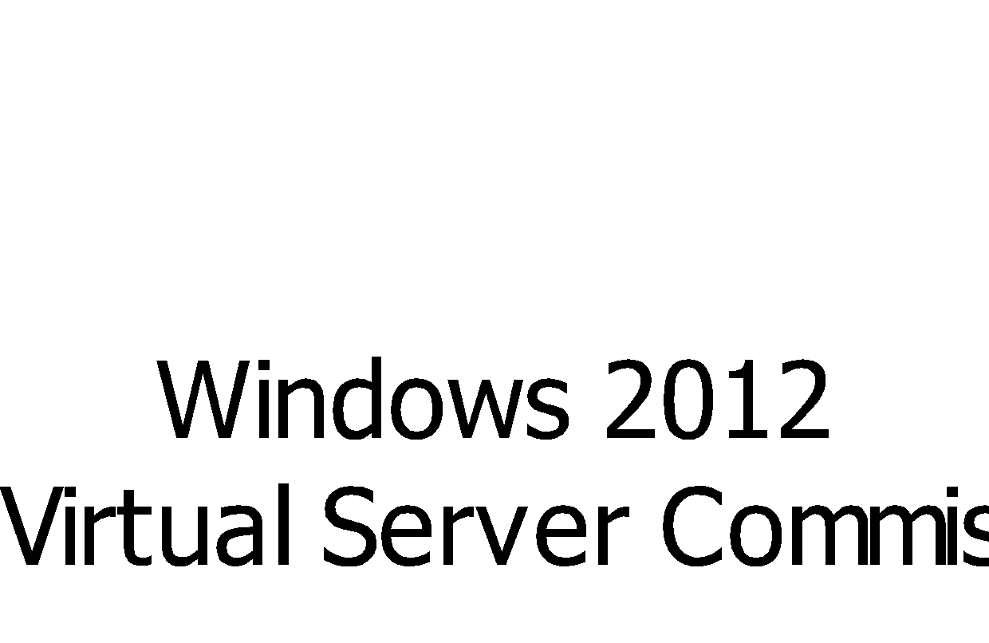 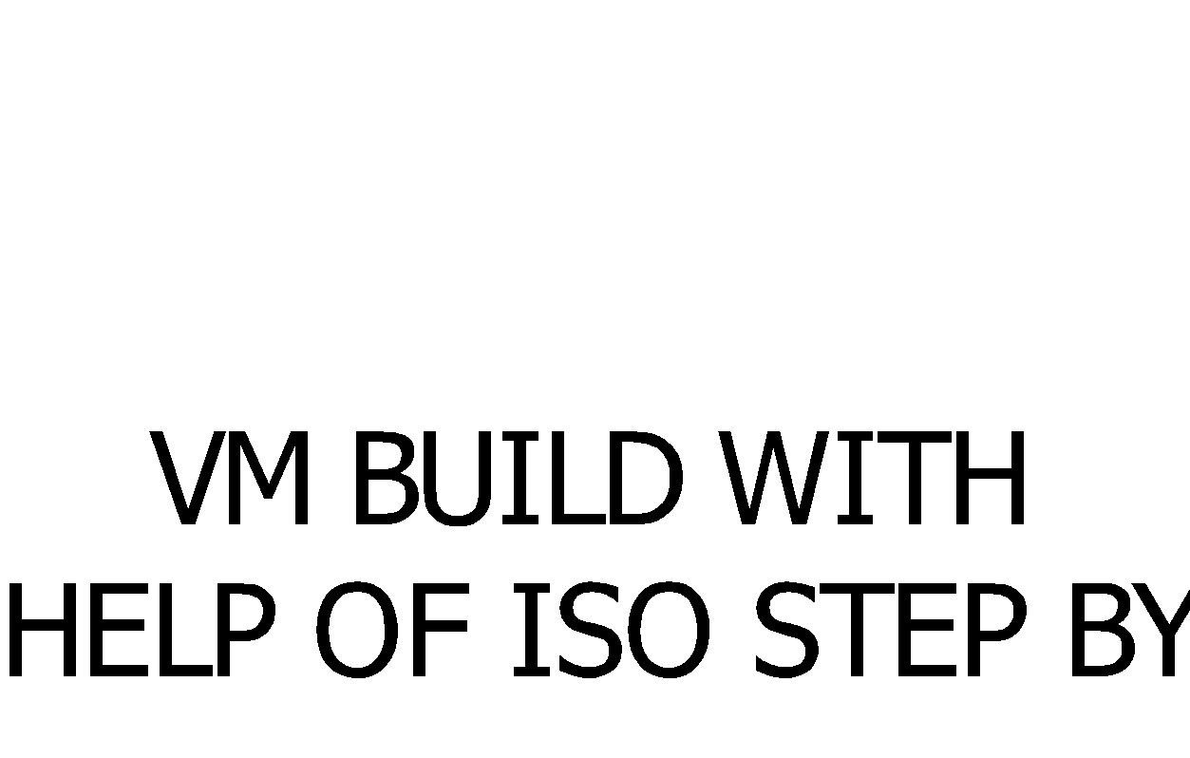

1. **What are default roles in vCenter? V.V.V.IMP**

Ans:

* No Access
* Read Only
* Administrator
* Virtual Machine Power User
* Virtual Machine User
* Resource Pool Administrator
* VMware Consolidated Backup User
* Datastore Consumer
* Network Consumer

1. **PORT NUMBERS?**

**PORT NUMBERS:-**

HTTP-80, HTTPS-443, NTP-123, FTP-21, SSH-22, SNMP-161,162, SMTP-25

Communication Port (OR) Heartbeat Port (OR) HA Agent (OR) VC Agent- 902.

LICENSE SERVER—27000 and 27010,

TCP/IP—7, UDP-17,

VMOTION-8000, LDAP-389, UPDATE MANAGER—80, 9000-9100

S/W ISCSI Client – 3260,

VMware HA Traffic (or) AAM Agent— 2050-2250, 8042-8045.

Web Service HTTP:8080,

Web Service HTTPS: 8443,

NFS—111, SSL—636

**WINDOWS PORT NUMBERS:-**

KERBEROS—88, DNS—53, LDAP—389, SPOP3—995, POP3—110, POP2—109, IMAP4—143

FTP—20 and 21, TELNET—23, IP-0, ICMP-1,

GGP-3, TCP-6, EGP-8, NFSD-2049,

PUP—12, UDP—17, RDP—27, RUD—66, DOMAIN (or) DNS (or) Name Server – 53,

BootPC (or) DHCP Client - 68, BootPS (or) DHCPS - 67, Gopher – 70, RTelnet -107, Auth -113,

NNTP - 119, NTP - 123, BGP - 179, IRC - 194, IPX - 213, KPASSWD - 464, LOGIN/WHO - 513

CMD - 514, NETWALL - 533, KLOGIN - 543, KSHELL - 544, LDAPS - 636, DOOM - 666,

KERBEROS ADMIN - 749, KPOP - 1109, PHONE - 1167, MS-SQL-S - 1433, WINS - 1512, MAN - 9535.

1. **ESX & ESXi Differences , Max Configurations and Hypervisor Differences? V.V.IMP.**

ANSWER:

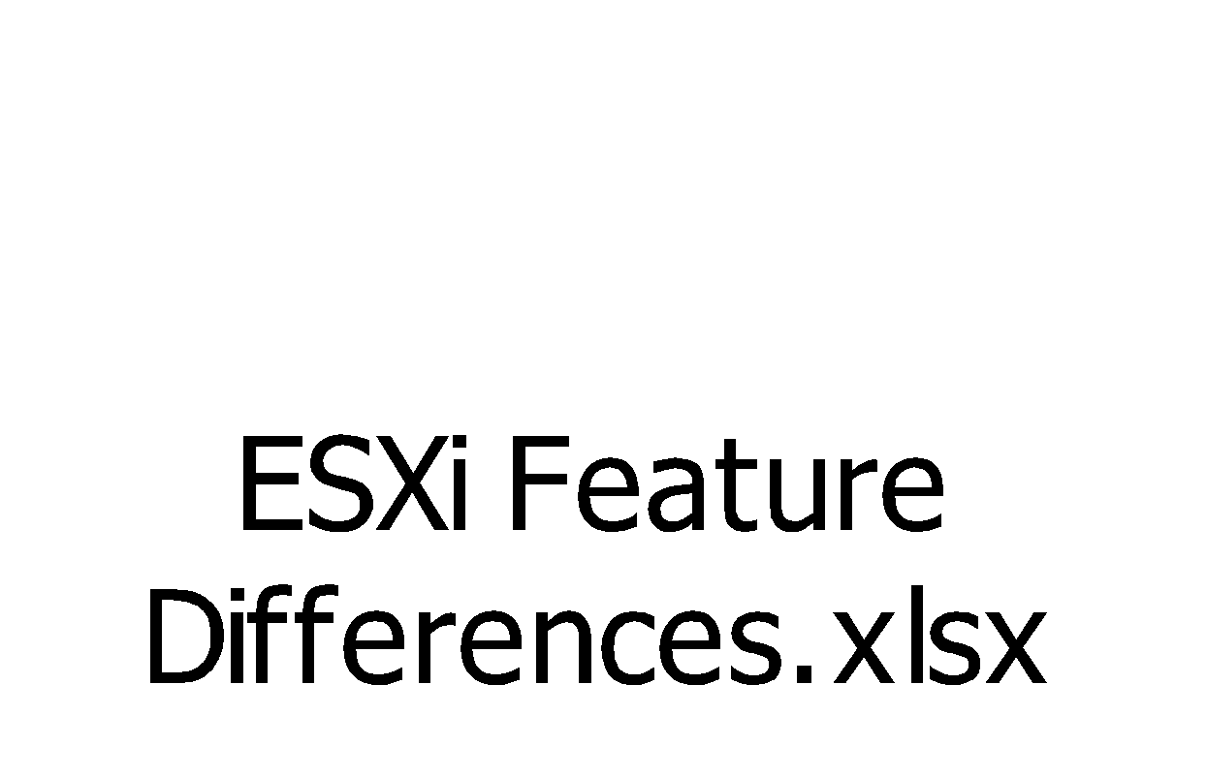

1. **How do you define syslog path?**

Ans:

We will configure the Syslog path in vCenter server during vCenter Installation paths are

**vCenter Server 5.5 and lower:**

 %PROGRAMDATA%\VMware\VMware Syslog Collector\vmconfig-syslog.xml

**vCenter Server 6.0:**

 %PROGRAMDATA%\VMware\vCenterServer\cfg\vmsyslogcollector\config.xml

1. **Resource Pool?**

Ans:

* A Pool of Resources reserved for a Virtual Machine
* We can Add Resource Pools in Host Level & Clustered Level
* In Host Level we can add up to 512 Resource pools & in Clustered level 128.
* While creation of a Resource Pool, it provides different options like Reservation, Share, Limited, Unlimited and Extent Options.

1. **Connections between ESX & VI Client and ESXi & VC vSphere Client?**

Ans:

**ESX vs VI CLIENT-🡪 HTTP & HTTPS: 80 & 443 & 902 & VPXA & HOSTD**

**ESXi vs vSphere Client🡪Heart Beat 902, vCenter Agent VPXA & Host Agent HOSTD.**

1. **What is Watch Dog and IP Tables**

Ans:

**Watchdog:**

This will use to check the UDP and TCP Port connection status for remote host whether Firewall rule is successful or failure.

**IP Tables**: Use iptables to gather current state

**ESXi HOST QUESTIONS & ANSWERS**

1. **Did you upgraded the ESXi ?**

Yes. With help of update manager I upgraded by created Baseline. (ESXiUpgradation)

1. **What are the pre requirement to upgrade the ESXi with help of update manager?**

Ans:

**Methods of Upgrading the ESXi Host:-**

* [vSphere Update Manager](http://kb.vmware.com/selfservice/microsites/search.do?language=en_US&cmd=displayKC&externalId=2058352#vum)
* [Upgrade or migrate interactively using an ESXi installer ISO image on CD/DVD or USB flash drive](http://kb.vmware.com/selfservice/microsites/search.do?language=en_US&cmd=displayKC&externalId=2058352#Upgrade%20or%20migrate%20interactively%20using%20an%20ESXi%20installer%20ISO%20image%20on%20CD/DVD%20or%20USB%20flash%20drive)
* [Scripted upgrade](http://kb.vmware.com/selfservice/microsites/search.do?language=en_US&cmd=displayKC&externalId=2058352#scriptedupgrade)
* [vSphere Auto Deploy](http://kb.vmware.com/selfservice/microsites/search.do?language=en_US&cmd=displayKC&externalId=2058352#autodeploy)
* [esxcli (Command-line interface)](http://kb.vmware.com/selfservice/microsites/search.do?language=en_US&cmd=displayKC&externalId=2058352#esxcli)

**PRIOR REQUIREMENTS**:-

1. Best practice is need to upgrade the vCenter first
2. Ensure that your current ESX/ESXi version is supported for migration or upgrade.

Example: (1) ESX 3.5 can be upgrade only for ESXi 4.1 not for ESXi 5.0

(2) ESXi 4.1 to ESXi 5.0,5.1& 5.5

1. Ensure that your system hardware complies with above ESXi requirements.
2. Ensure that sufficient disk space is available on the host for the upgrade minimum requires 50MB of free space on your VMFS datastore.
3. If a SAN is connected to the host, detach the fibre before continuing with the upgrade . Do not disable HBA cards in the BIOS.
4. Strongly recommendation is back up your host before performing an upgrade like host profile backup and take the configuration backup by logging into the host putty.  
     
   **Important**: After upgrading or migrating your host to ESXi 5.x, you cannot roll back to the earlier version.
5. Depending on the upgrade method , you may have to migrate or power off all virtual machines on the host.
6. **In Vcenter VM’s and ESXi not responding how you can fix?**

Ans: By restarting HostD and VPXA agents.

# /etc/init.d/hostd restart

# /etc/init.d/vpxa restart.

1. **What is your experience in PSOD? / What you can do when PSOD occurs? / why PSOD will occur?**

Ans:

**ESX HOST GOES DOWN (PSOD)**

1. Whenever PSOD will occur first will take a Photo / screenshot for safer.
2. Host failures mainly depend on Hardware (Machine check exceptions—MCE) & Memory (NMI ECC / Parity Error).
3. Like VMKernel& Service Console.
4. PSOD Comes by VMKernel Crash.
5. First we will access the server through ILO (If it is HP) / through iDRAC (if it Dell) then check the server status via remote console if it is hung state then will reboot the server from Power Management option.
6. After Host reboot will access the host by SSH (putty) to generate VMKernal Crash Log files
7. After Rebooting the ESX Host it will generate one core dump file i.e.”VMKernel Dump” under ROOT Directory.
8. We will use the command to generate Kernal Log #less /var/log /Kernaldump.
9. By using #VMKdump-l <VMKernel Dump Utility>. We can Extract Log File from Core Dump.
10. If we unable to identify the cause of the issue then will log a case with VMware support team and will upload the VMKernal Crash Logs for analyzing, so that VMware will provide an solution to fix the issue permanently.

Example: NIC Driver having an issue for PSOD in New York ESXi Environment.(ESXi5.1)

1. **If you want upgrade resources to your ESXi then how can perform?**

Ans:

We will perform Host Hardware upgradation with help of Maintenance Mode with CO.

1. **HA & DRS Cluster?**

ANSWER:

**VMOTION**

* **It is one of the VC feature.**
* **Moving running Virtual Machines from one ESXi Host to another ESXi Host without down time is called VMotion.**
* **VMotion works by Changes in Memory BitMap.**

**WHY WE GO FOR VMOTION**

**1. HOST MAINTENANCE PURPOSE**

* **While Updating ESXi / Host Updates.**
* **While increasing Service Console Memory up to 800 MB in ESX 3.5**
* **While adding any Hardware like: Memory, CPU, DISK and NIC.**

**In the above all conditions ESXi Host Reboot is required, so we have to Place ESXi / Host into Maintenance Mode.**

**2. CONTINUOUS VM OPERATIONS**

**Insufficient resources in our VM’s in that Scenario for VM continuous operations purpose better to move VM’s from one ESXi / Host to another ESXi / Host.**

**3. BETTER HARDWARE UTILIZATION**

**Insufficient resources in our ESXi Host in that Scenario better to move VM’s from One Host to another Host.**

**WHILE MOVING VM’s FROM ONE HOST TO ANOTHER HOST WE HAVE TO MEET SOME CONDITIONS.**

1. **CPU COMPATIBILTY (CPU should be same family either INTEL (or) AMD).**
2. **STORAGE SHOULD BE COMMON (or) SHARED STORAGE.**
3. **RESOURCES SHOULD BE AVAILABLE IN DESTINATION HOST.**
4. **PHYSICAL N/W SHOULD BE SAME NETWORK.**
5. **CREATE VMKERNEL PORT GROUP IN BOTH SOURCE & DESTINATION HOST’s.**
6. **NO ACCESS OF MOUNTABLE DEVICES EX: CD, FLOPPY.**
7. **NO PERMISSION TO VMX FILE.**

**SVMOTION**

**MOVING RUNNING VIRTUAL MACHINE DISK FILES FROM ONE SHARED STORAGE (Datastore) TO ANOTHER SHARED STORAGE (Datastore) IS CALLED SVMOTION.**

**HA**

* **It is one of the VC feature and Fail Over Mechanism.**
* **Used for Continuous Availability for VM’s**
* **While creation of Cluster in VC we have a Option HA Cluster.**
* **VC allows Virtual Machines to Migrate & Restart on another ESXi Host when the Host Fails.**

**WHILE MIGRATING VMs FROM ONE HOST TO ANOTHER HOST WE HAVE TO MEET SOME CONDITIONS.**

1. **CPU COMPATIBILTY (CPU should be same family either INTEL (or) AMD).**
2. **STORAGE SHOULD BE COMMON (or) SHARED STORAGE.**
3. **RESOURCES SHOULD BE AVAILABLE IN DESTINATION HOST.**
4. **PHYSICAL N/W SHOULD BE SAME NETWORK.**
5. **CREATE VMKERNEL PORT GROUP IN BOTH SOURCE & DESTINATION HOST’s.**
6. **HOST SHOULD BE CONFIGURED WITH FQDN**
7. **DNS SHOULD BE CONFIGURED WITH HOST NAME.**

**HA CONFIGURATION**

* **Right Click on Data Center/ Folder then click on New Cluster.**
* **Here we have Two Options one is HA (Failover Mechanism) & Second one is DRS(Load Balancing Mechanism).**
* **Provide Cluster name and Enable HA cluster.**
* **Enable Host Monitoring, Select HA Admission Control Enable,Select HA Admission Control Policy as Host Tolerance Min 1 & Maximum is 4 if its less than ESXi 5.5 . If it is ESXi 5.5 then Max host failover is 32.(Cluster Maximum Host also 32).**
* **VM Priority Default is ---Medium & Power On**
* **Cluster Default is recommended.**
* **Select Datastore Heartbeat.**

**DRS**

* **It is one of the VC feature and its main function is Load Balancing Mechanism.**
* **It balances the Virtual Machine Load across Hosts in the Cluster.**
* **While creation of cluster in VC we have option to create DRS cluster.**
* **In DRS cluster we can create resource pools.**
* **We can create resource pools either in standalone hosts (or) Clustered hosts.**
* **We can create 512 Resource pools under Host level, 128 under clustered.**

**DRS CONDITIONS.**

1. **CPU COMPATIBILTY (CPU should be same family either INTEL (or) AMD).**
2. **STORAGE SHOULD BE COMMON (or) SHARED STORAGE.**
3. **RESOURCES SHOULD BE AVAILABLE IN DESTINATION HOST.**
4. **PHYSICAL N/W SHOULD BE SAME NETWORK.**
5. **CREATE VMKERNEL PORT GROUP IN BOTH SOURCE & DESTINATION HOSTs.**
6. **HOST SHOULD BE CONFIGURED WITH FQDN**
7. **DNS SHOULD BE CONFIGURED WITH HOST NAME.**

**DRS CONFIGURATION**

* **First Login into VC .**
* **Right Click the Data Center.**
* **Select New Cluster Option.**
* **Here we have Two Options one is HA (Failover Mechanism) & Second one is DRS (Load Balancing Mechanism).**
* **Now Enable DRS cluster.-->after that we will get a wizard for .**
* **Automation Level Recommended is –Fully Automation.**
* **Coming to Migration Threshold Recommended is 3 (or) 4 Star.**
* **Select DRS Rules (Affinity/In-Affinity).**
* **Select VM automation level –PartialAutomation / Cluster Default Configuration**
* **Select VmSwapfile Location VM Directory Recommended.**
* **Click on Finish.**

1. **Is HA dependent on virtual center:**

Only for Install

1. **How does HA know to restart a VM from a dropped Host?**

Storage lock will be removed from the metadata

1. **What is the Maximum Host Failure allowed in a cluster?**

ESX 3.5 – 5.1 is🡪 4 & 5.5 is 🡪 32

1. **How Many IP Addresses required for Cluster Nodes?**

**HA Cluster 32 IP Addresses**

**DRS Cluster 32 IP Addresses.**

1. **Difference between TOP and ESXi TOP Commands**

* **VMware ESXITOP Command is used for Storage Monitoring**
* **ESXi TOP show the Service Console Performance (or) ESXi HOST performance.**
* **Monitors overall storage performance per HBA**
* **Monitors storage performance per LUN**
* **Monitors storage performance per VM**
* **Top command is used to shows how many users are logged in to Virtual Centre.**

1. **What are default roles in vCenter? V.V.V.IMP**

Ans:

* No Access
* Read Only
* Administrator
* Virtual Machine Power User
* Virtual Machine User
* Resource Pool Administrator
* VMware Consolidated Backup User
* Datastore Consumer
* Network Consumer

1. **How to Upgrade HOST without using update Manager?**

Ans:

By using Host Update Utility we can upgrade ESX if we do not have vCenter.

In Traditional process we can also do with the ISO known as Interactive Upgradation.

1. **Esxi environmental upgradation from Esxi 5.1 to Esxi 5.5?**

ANSWER:

Action Items      1: vCenter Server upgradation from vSphere 5.1 To vSphere 5.5 U2D

2: Upgrade Cisco Blade Firmware and drivers up to date on all 15 physical boxes.

3: Upgrade the ESXi host from ESXi 5.1.0 to ESXi 5.5.0 U2D with Help of Baseline.

4: Upgrade VMFS datastores from  VMFS 5.58 to VMFS 5.60

5: Upgrade VMware Tools. (Technology Recommendation)

6. Upgrade VM hardware version.

I would recommend that the Action Items 5 & 6  can  be performed separately because of we have to talk with the business to get server downtime during VM tools and VM hardware upgradation phase and also we should consider the good back out plan before proceeding on these tasks to avoid critical business impact.

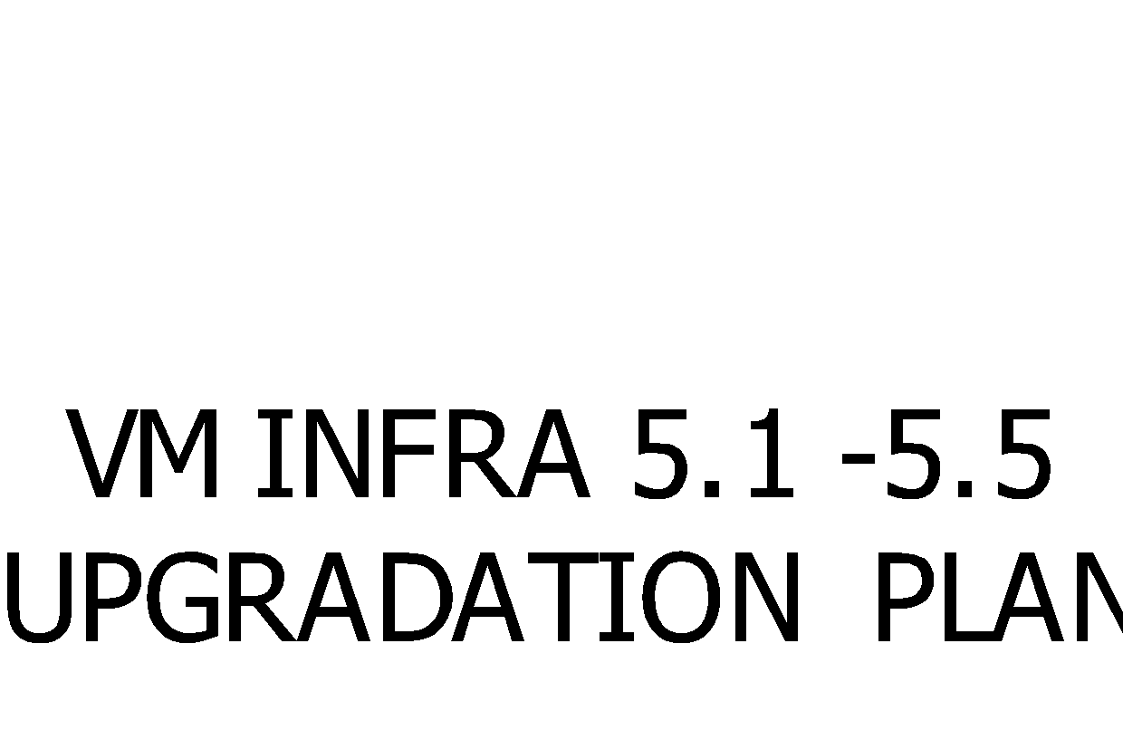

1. **How do I reset the root password from host profile?**

Ans:

Well it is because the vpxa user on each ESXi host has root privileges and it is added when the ESXi host is connected to vCenter  Server.

In this Post, i shall perform following tasks.

* Create host profile
* Configure the host profile
* Apply the Host Profile to the ESXi Host
* Verify your Host credentials

#### CREATE HOST PROFILE.

Right click any host in your inventory (it doesn’t matter which), choose **“Host Profile”**-> **“Create Profile from Host”**

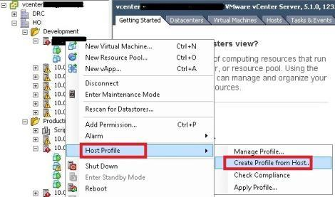

Give the host profile a name and description. Click **“Next”**.

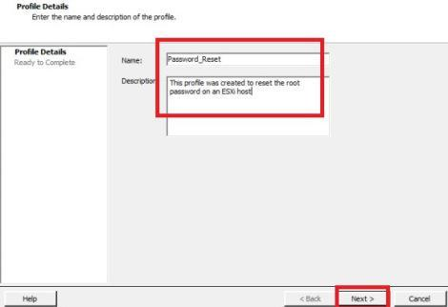

Click **“Finish”** to create the host profile.

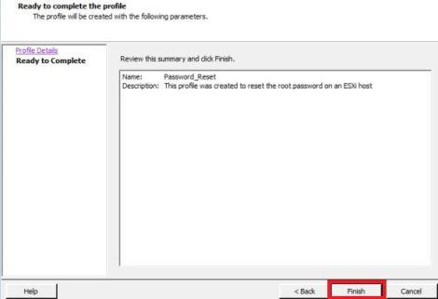

#### CONFIGURE THE HOST PROFILE:

Open the host profile

Go to home-> Management -> Host profile

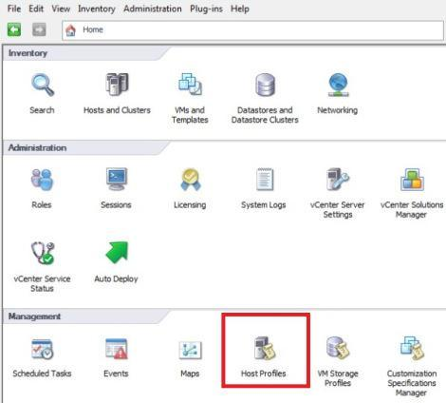

**“Right Click”** on the host profile (which i have just created) and choose **“Edit Profile”**

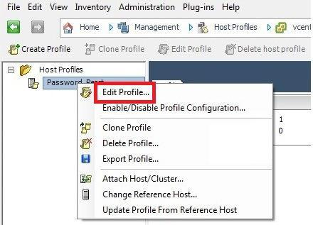

Expand **“Security Configuration”**-> Choose **“Administrator password”**

Select **“Configure a fixed administrator password”**, type in the **“administrator password twice”->** click **“OK”**.

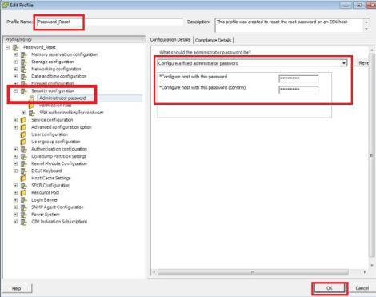

**“Right-click”** the Host Profile -> choose **“Enable/Disable Profile Configuration”**

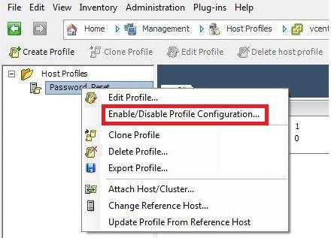

**“Uncheck”** everything in the Host Profile configuration except the **“Security Configuration”->** click **“OK”**

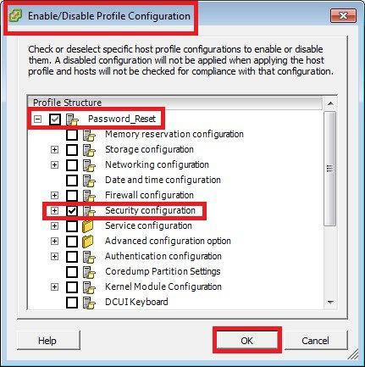

#### Apply the Host Profile to the ESXi Host:

Before apply the host profile into the ESXi Host. you should put ESXi host in maintenance mode. **“Right Click”** on the ESXi host -> **“Enter Maintenance Mode”**

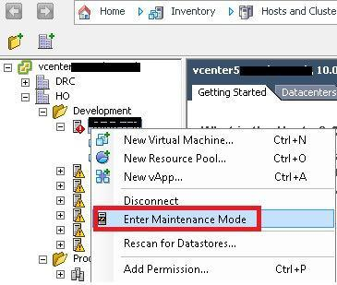

**“Right click”** on any host in your inventory-> choose **“Host Profile”**-> **“Manage Profile”**

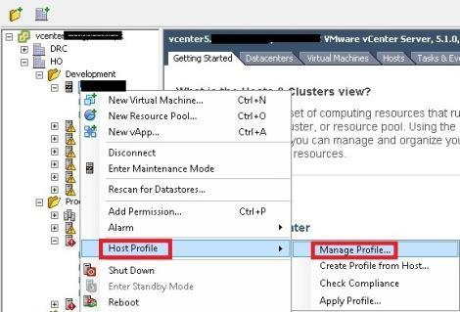

Choose your host profile in my case it is **“Password_Reset”** -> click **“OK”**

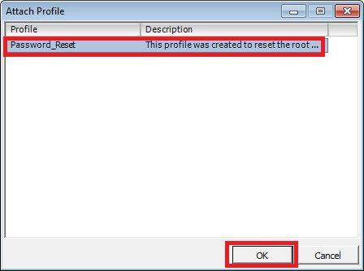

**“Right click”** on any host in your inventory -> Choose **“Host Profile” ->** Choose**“Apply Profile”**

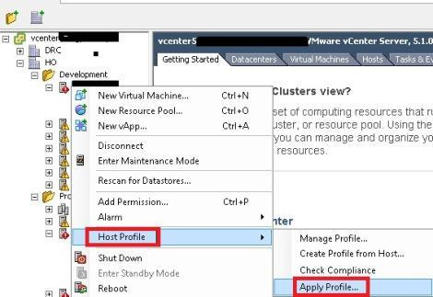

Check the changes to be applied (**only administrator password change should be applied**)->click **“Finish”**.

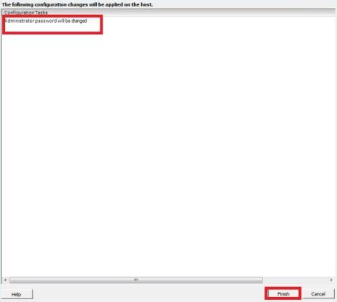

#### VERIFY YOUR HOST CREDENTIALS:

To verify you can log in with the new password. you should be able to log in with the new password immediately.

Login to the ESXi host with putty and enter the new credentials which you have justconfigured.if you are able to login to the host the its means your settings applied successfully.

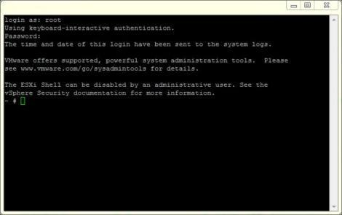

1. **What is the major difference between ESXi 4.1 and ESXi 5.5 Cluster.?**

| Features | vSphere 4.1 | vSphere 5.0 |
| --- | --- | --- |
| HA Agent | AAM Automatic Availability Manager | FDM Fault Domain Manager |
| HA Host Approach | Primary & Secondary | Master & Slave |
| HA Failure Detection | Management N/W | Management N/W and Storage communication |
| HA Log File | /etc/opt/vmware/AAM | /etc/opt/vmware/FDM |
| Storage DRS | Not Available | Yes |
| VM Affinity & Anti-Affinity | Available | Available |
| VMDK  Affinity & Anti-Affinity | Not Available | Available |
| Profile driven storage | Not Available | Available |
| VSphere Storage Appliance | Not Available | Available |
| Storage Vmotion Snapshot support | VM with Snapshot cannot be migrated using Storage vMotion | VM with Snapshot can be migrated using Storage vMotion |
| Swap to SSD | NO | Yes |
| Storage Vmotion | Moving VM Files using moving to using dirty block tracking | Moving VM Files using I/O mirroring with better enhancements |

**ESXi Commissioning**

1. We can insert the blade into the Chassis. If it is Rack, connect the rack into the core switch.
2. Request the Data Center operator to configure the remote board, ( ILO,DRACK, IMM,IRMC & KVM)
3. Once configured remote board with datacenter operator as per standard access server IP.

**Proceed on the installation by following methods:**

1. Interactive Installation.
2. ISO
3. Script
4. With the help of update Manager
5. Auto deploy.
6. To install Esxi we need to configure RAID and will configure the Raid 1 to install. While installation use LUN 0. ( LUN 0 is dedicated for Esxi installation and Choose default root password for best practice).

**Post Configuration:**

1. Configure Management IP.
2. Enable SSH to access putty.
3. Enable Esxi shell to perform troubleshooting.
4. Add the Esxi host into Vcenter as a standard host or clustered host.
5. Add storage / create data stores with customer naming standard.
6. Create network switches / add networking.
7. Configure Esxi License
8. Add Esxi host into domain
9. Enable or disable ports.
10. Start the required services and firewalls.
11. Configure the NTP.
12. Post build check list / Quality check.

**ESXi Decommissioning**

1. We need to migrate all virtual machines to another ESXi so keep host in Maintenance Mode.
2. Should send an email to storage team for Dezone the LUN's at SAN Level.
3. Unmount and Delete the datastores from ESXi, there should any LUN's visible on Decommission host.
4. Reboot Host by ILO and Login into BIOS and break the RAID.
5. Remove host from vCenter and shutdown ESXi with help of ILO
6. Remove AD Object.
7. Remove from Monitoring server,CI Database and Inventory.
8. Close the Change Order / Change Ticket.

**STORAGE QUESTIONS AND ANSWERS**

* 1. **How to present 1 TB storage on my ESXi ?**

Ans:

1. Will drop an email to storage team with ESXi host name & IP address (or) with all HBA WWN numbers to make the storage as shared storage at my all ESXi boxes.
2. Once storage team confirmed the 1 TB LUN with LUN ID then I can start adding storage at ESXi
3. Select ESXi and goto configuration tab🡪Select Storage in Hardware section and Click on Add Storage option.
4. Select LUN/DISK option and select new provisioned LUN
5. Format the LUN with VMFS-5 filesytem
6. Provide Datastore name according to the naming standard
7. Click on Next with 1 MB Block size and click on Finish.
8. Now the 1 TB LUN is visible for all ESXi boxes in the cluster.
   1. **What kind of storages you worked earlier / can support?**

Ans:

I can support on SAN and NAS (HPSAN,EMC(VNX),FUJISTU)

1. **What is difference between S/w iSCSI and H/w iSCSI?**

Ans:

Hardware iSCSI = HBA+Drivers(Supports to BOOT ESX)

Software iSCSI = NIC+Drivers(does not supports to BOOT ESX)

1. **How you can add SAN Storage?**

Ans:

1. I will check the storage availability in the existing datastores

2. If you dont have enough space for the existing request, then will send a request to the storage

team to provision the new LUN as a shared storage.

3. Here we can provide the HOST HBA WWN number/HOST IP address/Host name.

4. Storage team will provision the LUN and confirm the LUN ID with VMWare.

5. We will proceed to add the storage. HOST-->Configuration-->Hardware-->Storage-->Add

Storage.

6. Choose disk or LUN since its a LUN --> Choose Unallocated LUN-->Choose VMFS Filesystem

7. Provide Datastore name as per the standard -->Check Block size = 1MB(Universal Block size)

NOTE: The Blocksize differs before ESXi 5.0

256GB= 1MB Blocksize

512GB = 2MB Blocksize

1TB = 4 MB Blocksize

2TB = 8 MB Blocksize

1. **How you can add NAS Storage?**

Ans:

* I will check the storage availability in the existing datastores
* If you dont have enough space for the existing request, then will send a request to the storage team to provision the new VOLUME/MOUNTPOINTS as a shared storage.
* Here we can provide the HOST IP address/Host name/NAS box IP address.
* Storage team will provision the MOUNTPOINT and confirm the MOUNTPOINT PATH with VMWare.
* We will proceed to add the storage. HOST-->Configuration-->Hardware-->Storage-->Add Storage.
* Choose NFS since its a Netapp --> Choose Unallocated Mountpoint-->Choose VMFS Datastore.
* Select the provisioned volume and update the NAS Filler IP address.
* Provide Datastore name as per the standard -->Check Block size = 1MB(Universal Block size)

NOTE: The Blocksize differs before ESXi 5.0

256GB= 1MB Blocksize

512GB = 2MB Blocksize

1TB = 4 MB Blocksize

2TB = 8 MB Blocksize

1. **What are the major parameters you need to add SAN / NAS?**

**SAN = L**UN ID+Datastorename+Blocksize

**NAS** = Mountpoint+FillerIP+Datastore name

1. **Datastore Block sizes in ESXi4.1 &ESXi 5.1 /5.5?**

Ans:

ESX 3.5 to ESXi 4.1 (please refer below) and ESXi 5.0 - 5.5 Universal Blocksize is 1MB.

256GB= 1MB Blocksize

512GB = 2MB Blocksize

1TB = 4 MB Blocksize

2TB = 8 MB Blocksize

1. **What is VMFS?**

Ans:

* Its a VMWare file system it has two versions VMFS 3 and VMFS 5.
* ESXi 5.1 VMFS version is 5.58 and ESXi5.5 VMFS version is 5.60
* A VMFS data store is used to hold templates, ISO images and the files that make up a VM
* The size of a VMFS can be dynamically extended
* If the master extent is lost, it could cause data loss on the entire VMFS

1. **How you can upgrade your VMFS?**

Ans:

Datastoreupgradation is one of the key area during environmental upgradation. We can upgrade VMFS by choosing datastore section.

1. **LUN is not visibling at ESXi Level then how you can fix?**

Ans:

**Resolution:**

These steps assist you in identifying a LUN connectivity issue:

1. Verify that the LUN is presented to the ESXi/ESX host. You may need to contact your array vendor for assistance.
   1. Verify that the LUN is in the same storage group as all the ESXi/ESX hosts (if applicable to the array).
   2. Verify that the LUN is configured correctly for use with the ESXi/ESX host.  
        
      **Note**: Consult the appropriate SAN configuration guide for your array (listed in the Additional Information section).
   3. Verify that the LUN is not set to read-only on the array.
   4. Ensure that the HOST ID on the array for the LUN (on ESX it shows up under LUN ID) is less than 255 for the LUN. The maximum LUN ID is 255. Any LUN that has a HOST ID greater than 255 may not show as available under Storage Adapters, though on the array they may reside in the same storage group as the other LUNs that have host IDs less than 255. This limitation exists in all versions of ESXi/ESX from ESX 2.x to ESXi 5.x due to the fact that SCSI lun ID field in hexadecimal range 00 -FF (256). This information can be found in the maximums guide for the particular version of ESXi/ESX having the issue.
2. Verify that the ESX /ESXi host can see the LUNs..
3. Verify that a rescan restores visibility to the LUN's.
4. Check the storage for latency.
5. Verify that there are not excessive SCSI reservation conflicts. For more information, see:
6. **How you can delete Datastore?**

Ans:

* Make sure to perform SVMotion for the entire datastore
* Right click the Datastore🡪Unmount the datastore and delete the datastore
* Confirm the same to storage team to reclaim back to SAN box with NAA ID.

1. **what is maximum size of datastore& recommendation of VMware?**

Ans:

1TB is the recommended datastore size by the VMWare but I'm following in my infrastructure as 2TB.

1. **what is WWN Number?**

Ans:

World wide number reference of HBA. It's a unique number for HBA card, which will be the primary reference for storage team during new LUN Provisioning.

1. **VMWARE Storage Policies / Path Selection Policies (PSP)?**

The three default path selection policies (PSPs) are:

* **MRU (Most Recently Used)**. With this PSP the host selects the path that it used most recently. If the path becomes available the host selects an alternate path, but does not revert back to the original path once it becomes available again. MRU is the default policy for most active-passive storage devices.
* **Fixed**. With this PSP the host selects the preferred path if it has been configured. If not, it selects the first working path discovered when the host boots up. You can change the preferred path manually if you need to. Fixed is the default path selection policy for most active-active storage arrays.
* **Round Robin**. With this PSP the host rotates through using all active paths when connecting to active/passive arrays and through all available paths when connecting to active/active arrays. Round Robin can be used with either type of array and is used to implement load balancing across paths for different LUNs.

These pathing policies can be used with VMware ESXi 5.x and ESXi/ESX 4.x: DETAILS INFO.

* **Most Recently Used (MRU)**: The VMW_PSP_MRU policy selects the first working path, discovered at system boot time. If this path becomes unavailable, the ESXi/ESX host switches to an alternative path and continues to use the new path while it is available. This is the default policy for Logical Unit Numbers (LUNs) presented from an Active/Passive array. ESXi/ESX does not return to the previous path if, or when, it returns; it remains on the working path until it, for any reason, fails.  
    
  **Note**: The preferred flag, while sometimes visible, is not applicable to the MRU pathing policy and can be disregarded.
* **Fixed (Fixed)**: The VMW_PSP_FIXED policy uses the designated preferred path flag, if it is configured. Otherwise, it uses the first working path discovered at system boot time. If the ESXi/ESX host cannot use the preferred path or it becomes unavailable, the ESXi/ESX host selects an alternative available path. The host automatically returns to the previously defined preferred path as soon as it becomes available again. This is the default policy for LUNs presented from an Active/Active storage array.
* **Round Robin (RR)**: The VMW_PSP_RR policy uses an automatic path selection, rotating through all available paths, enabling the distribution of load across the configured paths.
  + For Active/Passive storage arrays, only the paths to the active controller will be used in the Round Robin policy.
  + For Active/Active storage arrays, all paths will be used in the Round Robin policy.

**Note**: For logical units associated with Microsoft Cluster Service (MSCS) and Microsoft Failover Clustering virtual machines, the Round Robin pathing policy is supported only on ESXi 5.5 and later.

* **Fixed path with Array Preference**: The VMW_PSP_FIXED_AP policy was introduced in ESXi/ESX 4.1. It works for both Active/Active and Active/Passive storage arrays that support Asymmetric Logical Unit Access (ALUA). This policy queries the storage array for the preferred path based on the array's preference. If no preferred path is specified by the user, the storage array selects the preferred path based on specific criteria.  
    
  **Note**: The VMW_PSP_FIXED_AP policy is removed from ESXi 5.x. For ALUA arrays in ESXi 5.0, the MRU Path Selection Policy (PSP) is normally selected but some storage arrays need to use Fixed. To check which PSP is recommended for your storage array, see the *Storage/SAN* section in the [VMware Compatibility Guide](http://www.vmware.com/resources/compatibility/search.php) or contact your storage vendor.

**Notes**:

* These pathing policies apply to VMware's Native Multipathing (NMP) Path Selection Plug-ins (PSP). Third-party PSPs have their own restrictions.
* Round Robin is not supported on all storage arrays. Please check with your array documentation or storage vendor to verify that Round Robin is supported and/or recommended for your array and configuration. Switching to an unsupported or undesirable pathing policy can result in connectivity issues to the LUNs (in a worst-case scenario, this can cause an outage).

**Warning**: VMware does not recommend changing the LUN policy from Fixed to MRU, as the automatic selection of the pathing policy is based on the array that is detected by the NMP PSP.

1. **What is NMP? (Native Multi Pathing)---PENDING**

Ans:

NMP (Native Multipath Plugin)

* The default MPP that comes with ESX,ESXI is the NMP. It manages some subplugins.
* The subplugins are SATPs (Storage Array Type Plugin) and the PSPs (Path Selection Plugin).
* Subplugins are either VMware default or 3rd party plugins (specific SATPs for specific arrays, e.g. VMW_SATP_SVC for IBM SVC Arrays).
* It associates SATP to paths, processes I/O requests to logical devices, performs failovers using SATP.

(OR)

1. **What does NMP do?**

* Manages physical path claiming and unclaiming
* Registers and de-registers logical storage devices
* Associates a set of physical paths with a specific logical storage device, or LUN
* Processes I/O requests to storage devices:
* Selects an optimal physical path for the request (load balance)
* Performs actions necessary to handle failures and request retries
* Supports management tasks such as abort or reset of logical storage devices.

NMP is an extensible module that manages subplugins: Storage Array Type Plugins (SATPs) and Path Selection Plugins (PSPs).

Storage Array Type Plugins (SATPs) is responsible for handling path failover for a given storage array. The appropriate SATP for an array you use will be installed automatically.

Path Selection Plugins (PSPs) determines which physical path is used to issue an I/O request to a storage device. SATPs and PSPs are sub plug-ins within the NMP module.

A Storage Array Type Plugin (SATP) determines how path failover is handled for a specific storage array.

**17. STORAGE CONCEPTS?**

ANSWER:

**Storage SAN, NAS, ISCSI Differences**

|  | **INTERFACE** | **TRANS** | **PROTOCOL** | **BOOTESXI** | **BOOTVM** | **VMOTION** | **HA/DRS** | **VCB** | **VMFS** | **PERFORMANCE** |
| --- | --- | --- | --- | --- | --- | --- | --- | --- | --- | --- |
| FC | FCHBA | LUN | FC/SCSI | YES | YES | YES | YES | YES | YES | HIGH |
| ISCSI | IScsiHBA | LUN | IP/SCSI | YES | YES | YES | YES | YES | YES | MEDIUM |
| NAS | NIC | FOL/FIL | TCP/IP | NO | YES | YES | YES | YES | NTFS | MEDIUM |
| LOCAL | NIC | SA/SCSI | TCP/IP | YES | YES | NO | NO | YES | YES | MEDIUM |

**VIRTUAL NETWORKING TOPICS**

* + 1. **Where we can configure VMotion?**

Ans:

VMotion will be configured in Network-->VSwitch-->VMKernel Port group🡪Edit🡪General🡪Enable the VMotion Check box.

1. **How many port groups we can create and explain each?**

Ans:

Management network port group: Used for ESXi communication from one network to another.

VMKernel port group: Responsible for VMotion and IP based storage (Outside communication).

VM port group: Responsible for communication of VM's within ESXi.

1. **What is difference between Standard and Distributed switches? (Short Description)**

Ans:

Standard switch is responsible for the individual ESXi hosts and we need to configure standard switch for each ESXi host.

Distributed switch is responsible for Centralized communication to enhance IO performance between ESXi hosts.

1. **What is difference between Standard and Distributed switches? (For Detailed Info)**

Ans:

Standard switch is responsible for the individual ESXi hosts and we need to configure standard switch for each ESXi host.

Distributed switch is responsible for Centralized communication to enhance IO performance between ESXi hosts.

| **Features** | **Standard Switch** | **Distributed Switch** |
| --- | --- | --- |
| Management | Standard switch needs to managed at each individual host level | Provides centralized management and  monitoring of the network configuration  of all the ESXi hosts that are associated with the dvswitch. |
| Licensing | Standard Switch is available for all  Licensing Edition | Distributed switch is only available for enterprise edition of licensing |
| Creation & configuration | Standard switch can be created and  configured at ESX/ESXi host level | Distributed switch can be created and configured  at the vCenter server level |
| Layer 2 Switch | Yes, can forward Layer 2 frames | Yes, can forward Layer 2 frames |
| VLAN segmentation | Yes | Yes |
| 802.1Q tagging | Can use and understand 802.1q VLAN tagging | Can use and understand 802.1q VLAN tagging |
| NIC teaming | Yes, can utilize multiple uplink to  form NIC teaming | Yes, can utilize multiple uplink to form  NIC teaming |
| Outbound Traffic Shaping | Can be achieved using standard switch | Can be achieved using distributed switch |
| Inbound Traffic Shaping | Not available as part of standard switches | Only possible at distributed switch |
| VM port blocking | Not available as part of standard  switches | Only possible at distributed switch |
| Private VLAN | Not available | PVLAN can be created as part of dvswitch. 3 types of PVLAN(Promiscuous,  Community and Isolated) |
| Load based Teaming | Not available | Can be achieved using distributed switch |
| Network vMotion | Not available | Can be achieved using distributed switch |
| Per Port policy setting | Policy can be applied at switch and port group | Policy can be applied at switch, port group and even per port level |
| NetFlow | Not available | Yes |
| Port Mirroring | Not available | Yes |

1. **Network security policies?**

**(a) Promiscuous Mode:- [REJECT]**

When we send a packet in network, I don’t want to broadcast and Listening my packet by other user in network expect my destination in prospective of security .Hence Reject is the recommendation of Promiscuous Mode.

**(b) MAC Address Changes**:- **[ACCEPT]**

By this security, when we transfer VM in network the MAC address of the Source Guest OS has the intended effect and destination frames will receivedthe new MAC address

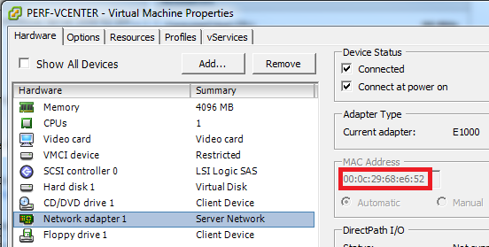

**(C)**  **Forged Transmits:- [ACCEPT]**

In this scenario, multiple virtual machines are participating in the NLB cluster and all have the same MAC address. Other cases revolve around the concept of utilizing a common MAC address to own a cluster resource when one or more nodes fail. Realistically, you won’t encounter all that many use cases that require Forged Transmits.

1. **What are the networking Bandwidth options available in VMware?**

Ans:

Traffic Shaping policy contains peak bandwidth, average bandwidth & burst size.

**REALTIME SCENARIOS AND TROUBLE SHOOTINGS**

1. Host Level
2. VM level
3. VC level
4. DS level
5. Network level

**ESXi Host Level**

**Scenario1:-**

**ESXi Host is not responding on network and disconnected from vCenter?**

## Unresponsive host and multiple Disconnected virtual machines (KB-1019082)?

**CAUSES:**

1. **Due to Physical connectivity loss**
2. **Due to running ENIC & FNIC with older firmware & Drivers.**
3. **Due to HostD non responsive state**
4. **Due to VPXA non responsive**
5. **Due to High Bandwidth during VM Scheduled backups and Network Switch backups.**
6. **Due to High Swap rate and High CPU utilzation.**

**RESOLUTION:-**

* **Verify the current state of the ESX/ESXi host hardware and power**
* **Determine if the ESX host responds to ping responses**
* **Verify that you can connect to the VMware ESX/ESXi host using vSphere Client**
* **ESX host has been rebooted**
* **Restart Management Agents .#/etc/init.d/hostd restart---(ESXi Hypervisor)**
* **Restart Management Agent #service mgmt-vmware restart (ESX Hypervisor)**
* **Restart vCenter Agent. #/etc/init.d/vpxa restart---- (ESXi Hypervisor)**
* **Restart vCenter Agent. #service -vmware vpxa restart (ESX Hypervisor)**
* **To Restart all Agents #./sbin/services.sh (or) #services -sh restart**
* **Need to upgrade the Bandwidth speed by customer.**
* **Need to increase Memory and CPU by keeping Host into Maintenance Mode**.

**Scenario2:-**

**ESXi 5.0 hosts are marked as Not Responding 60 seconds after being added tovCenter Server ( KB-2020100)**

**We can Fix by reconfiguring vCenter server with 902 Port .**

**How To configure vCenter Server to use port number 902:**

1. Stop the VMware VirtualCenter Server service. For more information, see [Stopping, starting, or restarting vCenter services (1003895)](http://kb.vmware.com/selfservice/search.do?cmd=displayKC&docType=kc&docTypeID=DT_KB_1_1&externalId=1003895).
2. Click Start > Run, type regedit, and click OK. The Registry Editor window opens.
3. Navigate to:  
     
   HKEY_LOCAL_MACHINE\SOFTWARE\VMware, Inc.\VMware VirtualCenter
4. Modify the registry key heartbeatport and change the value to 902.
5. Change the windows firewall to accept port 902:
   1. Navigate to Windows Firewall > Allow a program or feature through Windows firewall.
   2. Select VMware vCenter Server > Host Heartbeat.
   3. Click Details and change the port to 902 .
6. Start the VMware VirtualCenter Server service.  
     
   Note: The ESXi host may show as disconnected. Reconnect the host so that the new configuration info is saved to the vpxa.cfg file.

**Scenario 3:-**

## ESXi/ESX host appears as Not Responding in vCenter Server due to CD/DVD-ROM drive firmware issues (1017297)

* Upgrade the CD/DVD-ROM drive firmware to the latest version available
* Replace the CD/DVD-ROM drive with a different model
* Disable the CD/DVD-ROM drive within the BIOS of the ESXi/ESX host

**Scenario 4:-**

## ESXi/ESX hosts enter a Not Responding state after connecting to vCenter Server (1002719)

**A firewall prevents port 902 UDP heartbeats from the ESXi/ESX host from reaching the vCenter Server.  
  
This issue occurs when the ESXi/ESX host firewall or another firewall between the ESXi/ESX host and vCenter Server is configured to filter the UDP packets.  
  
Note: ESXi automatically opens its firewall when the vCenter Server agent is installed.  
  
To resolve this issue:  
  
For an ESX firewall:**

* 1. **Run this command to temporarily disable the ESX firewall and determine if it is blocking the port 902 UDP heartbeat packets:**

**# service firewall stop**

* 1. **Start the firewall with service firewall start.**

**Scenario 5:-**

**I am unable to access ESXi by Putty , what could be the reason?**

Ans: Your SSH service and SSH Port is not enabled/ opened.

**Scenario 6:-**

**I am unable to keep my ESXi 4.1 Host in Maintenance Mode ?**

Ans:

1. Your ESXi Host Virtual Machines might have Snapshots / RDM’s (or) Both.
2. So you have to commit / Revert VM snapshot before Host Maintenance Mode.
3. You need to power of the RDM virtual machine before Keep ESXi in Maintenance Mode otherwise Remove the RDM Disk from the VM and initiate Host Maintenance Mode after that add the same RDM to your virtual machine after migration.
4. If any virtual machine VMDK is locked by ESXi Host you can’t keep ESXi Host into Maintenance Mode; so we have reboot the Host after migrated rest VM’s to fix this issue.

**Scenario7:-**

**My ESXi Host resources (Memory & CPU) showing 0% at vCenter, what is this behavior and how you will fix this.**

Ans: By Restarting HostdAgent service and By Restarting vCenter Agent service we can fix.

Restart Management Agents . #/etc/init.d/hostd restart

Restart vCenter Agent. #/etc/init.d/vpxa restart

**Scenario8:-**

**I am unable to keep my ESXi 5.1 Host in Maintenance Mode, what could be the problem?**

* + 1. Virtual Machine have RDM.
    2. The VM is locked by ESXi Host.

**Scenario 9:-**

**Your Master Node has been down, what will happen?**

1. The master node VM's can rebooted

2. Your Master Host failed communication to your HA Agent so there is possibility of your cluster communications , which means all your Slaves are out of your HA & DRS. (HA will failed all ESXi Slaves)

3. You need to reboot Faulty Master to select a new Master by Election.

**Scenario 10:-**

**Suppose my ESXi host hardware tab is not displaying the hardware status then what is service need to restart?**

* CIM service on the ESXi host should be restarted / Enable Plugin

**Scenario 11:- I am unable to take my esxi by putty?**

Ans:

Might be your SSH service is disabled on host / the SSH Incoming and outgoing port is not active due to this we unable to take Host by PUTTY

2. **Virtual Machine Level**

**Scenario1:-**

**I am unable to Migrate VM to another ESX / ESXi Host and unable to increase drive C: & D: space and all VM Options are inactive state**

Ans:-

* You might have the snapshot in your virtual machine .Hence we unable to perform vmotion which is applicable until ESXi 4.1 so upto ESXi 4.1 the snapshot virtual machine can't migrate and also physical RDM is one of the reason.
* If you have snapshot to your virtual machine you can't able to increase C: & D: space in all hypervisors.

**Scenario 2:-**

**VM performance is degraded what are the cause and how you can remediate.**

**I)**

1. Resources Crunch

* Resource should be unlimited in production VM Should not enable ballooning.

1. Data store No space

* In production, always choose thick provision.

1. VM Tool outdated

* VM tools help to provide the best performance for mouse, memory,time synchronization, graceful shutdown & restart

1. Lower virtual machine hardware version

* Upgrade the VM hardware versions

1. VM network adapter lower version like E1000 (100 Mbps)

* Updating VM tools will give latest version and also we can add new vnic as vmxnet2 (or) vmxnet3.

1. Older Hypervisor and drivers

* Use update manager and perform environment upgrade.

1. VM Heartbeat failure

**Symptoms:**

* VM out of HA
* VM can't migrate any where
* VM out of VMware feature and DRS not supporting

**Why & How (Reasons)**

* Vmdk locked
* base CPU & memory controlled by ballooning
* Heavy network traffic due to read & write.
* Due to ESXi NIC and HBA drivers & Firmwares.

**Solutions:**

* Need to find the particular VM residing and reconfigure in particular host
* Reconfigure HA in particular host
* if not recovered, do the manual Vmotion
* Restart the HOST D agent, by login putty.

**CMD:** # /etc/init.d/hostd restart (ver 5.0)

# service MGMT-Vmware Restart (up to ver 4.1)

* Finally restart the VM , will fix most of the problem

II) **VM level:**  Guest OS performance:

Perform upgrade OS and installing patches.This will be taking care by Windows team.

III) **VM level:** Unable to power ON VM

* Low disk space in datastore
* Network adapter lower version.
* ESXi host doesn't have the enough memory

**Scenario2:-**

**VM unable to do the vmotion from one host to another host/ VM vMotion failed?**

1. VM Should meet vmotion 5 conditions.

2. VM should not contain any snapshot if ESXi is 3.5,4.0 & 4.1. If you have snapshot then we need to commit/Delete (or) Revert Snapshot to finish vmotion. Incase your ESXi is 5.0,5.1,& 6.0 then snapshot vm vmotion can be possible .

3. VM Should not contain any physical RDM, since physical RDM is SCSI file system. Virtual RDM Can able to do the vmotion without downtime because of virtual RDM is VMFS file system.

4. Few cases vMotion will be failed at 27% by HA Cluster Configured so we need to disable the HA Cluster until vMotion activity.

5. If VMDK is Locked we can't able to do the vmotion, so we need to kill the VM process to perform vmotion. #kill -i (Ex: #kill -9)

6. If vSwitches network port group Lable names are differ in destination ESXi host then we can't able to do the vmotion.

7. If the destination ESXi Host Virtual Machine port group does not contain respective port group VLAN ID configuration then vmotion will be failed.

8. If vCenter is down then vmotion won't work.

9. We need to enable the vMotion & Management Traffic on vSwitches of Host.

10. vMotion is failing at 14% (or) vMotion getting an error as vmkernel network need to check

11. Virtual Machine contains sparse disk.

**Scenario3:-**

**What happen if VMotion stops in between 10% and how to fix it?**

**CAUSE: This issue may also occur due to a duplicate IP address on your network**

**RESOLUTION :To reset the Migrate.Enabled setting:**

1. Connect vSphere or VMware Infrastructure Client to your vCenter Server.
2. Click on the ESX host.
3. Click the Configuration tab.
4. Click Advanced Settings under Software.
5. Select Migrate and change Migrate.Enabled to 0.
6. Click OK and close.
7. Click on Advanced Settings.
8. Select Migrate and change Migrate.Enabled to 1.
9. Click OK and then Close.

If these steps do not resolve the issue, try increasing the timeout for migration network operations after Step 4 and then continue with the remaining steps. Also, ensure to repeat these steps on the destination host.

To increase the timeout for migration network operations:

1. Click the Configuration tab.
2. Click Advanced Settings under Software > Migrate.
3. Change Migrate.NetTimeout to 60 seconds. The default is 20 seconds.
4. Click OK and then Close.

**Scenario 4: How we will convert Thin to Thick provisioning of VMDK.**

**Scenario 5: How to fix vm inventory name differs in datastores.**

**Scenario 6: How to split the vmdk of virtual machine to different datastores .**

**The above 3 scenarios can able to fix by SVmotion.**

Right click on VM--> Select Migrate-->Choose-->Change Datastore-->Click on Advanced--> Select different datastore--> Change Provisioning Thick to Thin.

**VIRTUAL MACHINE TROUBLESHOOTINGS BRIEF REFERENCES (OPTIONAL)**

1. **Troubleshooting a virtual machine that has stopped responding (1007819):-**

**Symptoms:**

* Guest OS does not respond to keyboard or mouse activity at the console.
* Guest OS does not respond to network communication, including ping, RDP, SSH, etc.
* Virtual machine console screen is static, and does not change or refresh.
* Tasks performed on the virtual machine fail, timeout, or do not start.
* Virtual machine does not produce network or disk traffic.

**RESOLUTION:**

**Identify the Cause:**

1. Determine whether the problem is triggered by an operation or task being performed on the virtual machine. For example, snapshot and vMotion operations both stun a virtual machine for brief periods of time while memory state is copied across the network or to disk
2. Some common configuration errors can lead to a virtual machine becoming unresponsive, such as while waiting for a resource
3. Virtual machines depend on functional backing infrastructure. If there is an issue with the backing storage or networking infrastructure which the virtual machine depends on, the virtual hardware which a virtual machine presents to the guest OS may be impacted. Address the underlying storage or networking issue
4. Virtual machines depend on available host resources (CPU, Memory), and the guest OS consumes those resources. A problem with resource availability or scheduling inside or outside the virtual machine may cause it to become unresponsive. The virtual machine may also be blocking on unavailable resources or spinning at 100% vCPU utilization
5. **Troubleshooting virtual machine network connection issues (1003893)**:-

**Symptoms:**

* Virtual machines fail to connect to the network.
* There is no network connectivity to or from a single virtual machine.
* A TCP/IP connection fails to and from a single virtual machine.

You may see one or more of the following errors:

* + Destination Host Unreachable
  + Network error: Connection Refused
  + Network cable is unplugged
    - 1. Ensure that the Port Group name(s) associated with the virtual machine's network adapter(s) exists in your vSwitch or Virtual Distributed Switch and is spelled correctly. If not, correct it using **Edit Settings** on the virtual machine and ensure that the **Connected** checkbox is selected
      2. Ensure that the virtual machine has no underlying issues with storage or it is not in resource contention, as this might result in networking issues with the virtual machine.
      3. Verify that the virtual network adapter is present and connected
      4. Verify that the networking within the virtual machine's guest operating system is correct
      5. Verify that the TCP/IP stack is functioning correctly
* Ping and Loopback address to verify that TCP/IP is working correctly.
* Check for duplicate IP and TCP/IP driver issues
* Cleare Address Resolution Protocol (ARP)
* Verify the default gateway
* Check Firewall (Internal & External) configuration
* Check VSwitch VLAN configuration
* Verify physical switch port security
* Use the TCPDUMP network traffic monitoring command to sniff TCP/IP
  + - 1. If this virtual machine was converted from a physical system, verify that there are no hidden network adapters present
      2. Verify that the vSwitch has enough ports for the virtual machine
      3. Verify that the virtual machine's IPSec configuration is configured correctly and that it is not corrupted

1. **Troubleshooting a virtual machine that is unable to power on (2001005)**:-

**Resolution:**

1. The virtual machine monitor may be asking a question to be answered during startup. A virtual machine may pause the power-on task at 95% to obtain additional information from the administrator
2. A virtual machine may fail to power on if licensing requirements are not met
3. The virtual machine may be configured to reserve physical memory on the host, but the host memory is over-committed and the required memory is unavailable.
4. The virtual machine may be starting in a VMware High Availability cluster with strict admission control enabled, and there are insufficient resources to guarantee failover for all virtual machines
5. A file required for starting the virtual machine, such as a virtual disk or swap file, may be unavailable or missing
6. The virtual machine may require both a VT-capable CPU and the VT feature to be enabled in the host system's BIOS
7. If the virtual machine does successfully power on, but the guest OS doesn't start correctly, there may be an incompatibility between the virtual hardware and drivers within the guest OS
8. **Gueset OS not responsive**: Verify sufficient disk space for proper virtual machine operation. One of the most common causes for a virtual machine to become unresponsive is that the hard drive has run out of space
9. **Investigating virtual machine file locks on ESXi/ESX (10051)**:-

**Symptoms:**

* A virtual machine cannot power on.
* Powering on a virtual machine fails.
* Unable to power on a virtual machine.
* Adding an existing virtual machine disk (VMDK) to a virtual machine that is already powered on fails with the error:  
    
  Failed to add disk scsi0:1. Failed to power on scsi0:1

**When powering on the virtual machine, you see one of these errors:**

* + Unable to open Swap File
  + Unable to access a file since it is locked
  + Unable to access a file *<*filename*>* since it is locked
  + Unable to access Virtual machine configuration

**In the /var/log/vmkernel log file, you see entries similar to:**  
  
WARNING: World: VM xxxx*:* xxx*:* Failed to open swap file *<*path*>*: Lock was not free  
WARNING: World: VM xxxx*:* xxx*:* Failed to initialize swap file *<*path*>*

**When opening a console to the virtual machine, you may receive the error:**Error connecting to *<*path><virtual machine*>*.vmx because the VMX is not started

* Powering on the virtual machine results in the power on task remaining at 95% indefinitely.
* Cannot power on the virtual machine after deploying it from a template.
* The virtual machine reports conflicting power states between vCenter Server and the ESXi/ESX host console.

**Attempting to view or open the .vmx file using a text editor (for example, cat or vi), reports an error similar to:**  
cat: can't open '*[*name of vm]*.vmx'*: Invalid argument

1. **The purpose of file locking**

To prevent concurrent changes to critical virtual machine files and file systems, ESXi/ESX hosts establish locks on these files. In certain circumstances these locks may not be released when the virtual machine is powered off. The files cannot be accessed by the servers while locked, and the virtual machine is unable to power on.  
  
**These virtual machine files are commonly locked during runtime:**

* VMNAME.vswp
* DISKNAME-flat.vmdk
* DISKNAME-ITERATION-delta.vmdk
* VMNAME.vmx
* VMNAME.vmxf
* vmware.log

**Solution**:

To get your critical virtual machine running:

1. Migrate the virtual machine to the host it was last known to be running on and attempt to power on.
2. If unsuccessful, continue to attempt a power on of the virtual machine on other hosts in the cluster.  
   When you hit the host holding the file locks, the virtual machine should power on as the file locks in place are valid.
3. If you still cannot power on the virtual machine continue with the steps below to investigate in more detail.
4. **How to Identify Locked file in VM**:

To identify the locked file, attempt to power on the virtual machine. During the power on process, an error may display or be written to the virtual machine's logs. The error and the log entry identify the virtual machine and files.

* 1. Log in as root to the ESXi host using an SSH client.
  2. Confirm that the virtual machine is registered on the server and obtain the full path to the virtual machine, run this command:  
       
     #vim-cmd vmsvc/getallvms  
       
     The output returns a list of the virtual machines registered to the ESXi host. Each line contains the datastore and location within of a virtual machine's .vmx file. The output is similar to:  
       
     *[*datastore*]* VMDIR*/*VMNAME*.vmx*  
     Verify that the affected virtual machine appears in this list. If it is not listed, the virtual machine is not registered on this ESXi host. The host on which the virtual machine is registered typically holds the lock. Ensure that you are connected to the proper host before proceeding.
  3. Move to the virtual machine's directory:  
       
     # cd /vmfs/volumes/datastore/VMDIR
  4. Use a text viewer to read the contents of the vmware.log file. At the end of the file, look for error messages that identify the affected file.

1. **How to Remove Locked File in VM**:

A virtual machine can be moved between hosts, because of this the host where the virtual machine is currently registered may not be the host maintaining the file lock. The lock must be released by the ESX/ESXi host that owns the lock. This host is identified by the MAC address of the primary management vmkernel interface.  
  
**Note:** Locked files can also be caused by backup programs keeping a lock on the file while backing up the virtual machine. If there are any issues with the backup it may result in the lock not being removed correctly. In some cases you may need to disable your backup application or reboot the backup server to clear the hung backup.  
  
This lock can be maintained by the VMkernel for any hosts connected to the same storage.

**3. VCENTER LEVEL TROUBLESHOOTINGS**

* **VPXD not responding**

Need to check VC server depending services like workstation, SQL, Storage & Orchestrator, webservices,virtual storage drive.

* **VCDB(VC database) /SSO full**

VCDB default Size is 4GB(if VC & VCDB installed in same PC) and need to delete 'Log files' in 'ARG' table.

To check the VCDB full need to go for 'Event Viewer'

* **VCenter down**

If Vcenter is down, then Vmotion, DRS, SVmotion wouldn't work.

FT and HA will work.

First take a clone VCenter if any major changes for safety purpose .

Shutdown & Restart.

**4.STORAGE LEVEL TROUBLESHOOTINGS**

* + 1. **LUN not visibling at ESXi Level then how you can fix?**
  + Recheck with storage team for properly done Masking & Zoning.
  + Rescan the HBA. Physical HBA card may damaged.

Ans:

**Resolution:**

These steps assist you in identifying a LUN connectivity issue:

1. Verify that the LUN is presented to the ESXi/ESX host. You may need to contact your array vendor for assistance.

* 1. Verify that the LUN is in the same storage group as all the ESXi/ESX hosts (if applicable to the array).
  2. Verify that the LUN is configured correctly for use with the ESXi/ESX host.  
       
     **Note**: Consult the appropriate SAN configuration guide for your array (listed in the Additional Information section).
  3. Verify that the LUN is not set to read-only on the array.
  4. Ensure that the HOST ID on the array for the LUN (on ESX it shows up under LUN ID) is less than 255 for the LUN. The maximum LUN ID is 255. Any LUN that has a HOST ID greater than 255 may not show as available under Storage Adapters, though on the array they may reside in the same storage group as the other LUNs that have host IDs less than 255. This limitation exists in all versions of ESXi/ESX from ESX 2.x to ESXi 5.x due to the fact that SCSI lun ID field in hexadecimal range 00 -FF (256). This information can be found in the maximums guide for the particular version of ESXi/ESX having the issue.
     1. Verify that the ESX /ESXi host can see the LUNs..

1. Verify that a rescan restores visibility to the LUN(s.Check the storage for latency.Verify that there are not excessive SCSI reservation conflicts.

Note: LUN missing visibility at the time of ESXi Upgradation.

**NETWORK LEVEL TROUBLESHOOTING**

* + Uplink redundancy & connectivity status. Without Redundancy never configure the VSwitch.

**vMotion Failing**:

* + Management & vMotion port Configuration option should be selected
  + Port group label names should be Case Sensitive
  + NIC Teaming: Combine all physical NICs and use as one logical uplink for Vswitch.NIC teaming is the load Balancing and Failure

**VMWARE MAJOR COMMANDS FOR INTERVIEW**

**Using Log files for Troubleshooting of when ESXi Down**

**Log files are generally your best tool for troubleshooting any type of problem. ESX has many log files. Which ones you should check depends on the problem you are experiencing. Below is the list of ESX log files that you will commonly use to troubleshoot ESX server problems. The VMkernel and hosted log files are usually the logs you will want to check first**.

* **VMkernel** - #/var/log/vmkernel – Records activities related to the virtual machines and ESX server. Rotated with a numeric extension, current log has no extension, most recent has a ".1" extension.
* **VMkernel Warnings** - #/var/log/vmkwarning – Records activities with the virtual machines, a subset of the VMkernel log and uses the same rotation scheme.
* **VMkernel Summary** - #/var/log/vmksummary - Used to determine uptime and availability statistics for ESX Server; readable summary found in /var/log/vmksummary.txt.
* **ESX Server host agent log** - #/var/log/vmware/hostd.log - Contains information on the agent that manages and configures the ESX Server host and its virtual machines. (Search the file date/time stamps to find the log file it is currently outputting to, or open hostd.log, which is linked to the current log file.)
* **ESX Firewall log** - #/var/log/vmware/esxcfg-firewall.log – Logs all firewall rule events.
* **ESX Update log** - #/var/log/vmware/esxupdate.log–Logs all updates done through the esxupdate tool.
* **Service Console** - #/var/log/messages - Contains all general log messages used to troubleshoot virtual machines or ESX Server.
* **Web Access** - #/var/log/vmware/webAccess- Records information on web-based access to ESX Server.
* **Authentication log** - #/var/log/secure - Contains records of connections that require authentication, such as VMware daemons and actions initiated by the xinetd daemon.
* **Vpxa log** - #/var/log/vmware/vpx - Contains information on the agent that communicates with VirtualCenter. Search the file date/time stamps to find the log file it is currently outputting to or open hostd.log which is linked to the current log file.

-------------------------------------------------------------------------------------------------------------------------------

1. What is command to add the new port group  named (mgmt)to vswitch (vswitch 3) ?

[root@ESXTEST1 sbin]# esxcfg-vswitch -A mgmt vswitch3

1. To list the services currently controlled by the firewall? #esxcfg-firewall -s.
2. Open a port? #esxcfg-firewall -o 465,tcp,out,out-smtps
3. Close a port? #esxcfg-firewall -c 465,tcp,out

**COMMANDS FOR SINGLE FUNCTION**

**# vim-cmd vmsvc/**

**Commands available under vmsvc/:**

acquiremksticket get.snapshotinfo

acquireticket get.spaceNeededForConsolidation

connect get.summary

convert.toTemplate get.tasklist

convert.toVm getallvms

createdummyvm gethostconstraints

destroy **login**

device.connection **logout**

device.connusbdev message

device.disconnusbdev power.getstate

device.diskadd power.hibernate

device.diskaddexisting power.off

device.diskremove power.on

device.getdevices power.reboot

device.toolsSyncSet power.reset

device.vmiadd power.shutdown

device.vmiremove power.suspend

devices.createnic power.suspendResume

disconnect queryftcompat

get.capability reload

get.config setscreenres

get.config.cpuidmask snapshot.create

get.configoption snapshot.dumpoption

get.datastores snapshot.get

get.disabledmethods snapshot.remove

get.environment snapshot.removeall

get.filelayout snapshot.revert

get.filelayoutex snapshot.setoption

get.guest tools.cancelinstall

get.guestheartbeatStatus tools.install

get.managedentitystatus tools.upgrade

get.networks unregister

get.runtime upgrade

1. **esxcfg-init**

[root@esx1 root]# esxcfg-init -h  
Usage: esxcfg-init  
This program is used to initialize device names and advanced configuration options for the VMkernel on system boot.It is NOT intended for use outside of initialization scripts.

1. **esxcfg-nas**

# esxcfg-nas -l --->this will display  list of mounted NAS file systems with data-store name.

#  esxcfg-nas -d <data-store name> --> Unmount (delete in esxcfg-nas term)  the “inactive” NAS data-store:

Then to remount (add) data-store in ESXi:

# esxcfg-nas -a <data-store name> -o <host-name or ip-address of NAS> -s <NAS share-path>

**INTERVIEW 100% EXPECTED COMMANDS**

* #vicfg-cfgbackup.pl -server ESXi-IP -username root -password <password> –save c:\dir\backupfile.txt--> ESXi Backup
* **vmkfstools -c 2048m testdisk1.vmdk ---> To create VMDK with help of vmkfstools command.**
* vmkfstools -i "/vmfs/volumes/Datastore/examplevm/examplevm.vmdk" "/vmfs/volumes/Datastore 2/newexamplevm/newexamplevm.vmdk" -d thin -a buslogic ---> Cloning and Converting VM Disk.
* What is the command to check number of nics in esx3 & 4? # esxcfg-nics –l / esxcfg-vmknic –l
* What is the command to configure IP Address & modify service console in ESX? # esxcfg-vswif-l
* What is command to add the new virtual switch named (vswitch3) to our ESX server?

[root@ESXTEST1 sbin]# esxcfg-vswitch -a vswitch3----To add new vswitch.

* How to change  the  ESX host name and default gateway?

By editing the following file: #nano  /etc/sysconfig/network

* what is the command to query the firewall ports ? #esxcfg-firewall – q
* How  to open the port in firewall? #esxcfg-firewall -o 8877,tcp,in,test3.
* Reset the firewall with the command? #esxcfg-firewall -r
* Enable a service? #esxcfg-firewall -e [servicename]
* Disable a service? #esxcfg-firewall -d [servicename]
* What is the command to restart esx firewall? #esxcfg-firewall -r
* Restart Management Agents #/etc/init.d/hostd restart---(ESXi Hypervisor)
* Restart Management Agent #service mgmt-vmware restart (ESX Hypervisor)
* Restart vCenter Agent #/etc/init.d/vpxa restart
* To Restart all management agents and services on Host

#/sbin/services.sh restart (or) #services.sh restart

* To display all HBA details. **#vmkchdev -l | grep vmhba**

* To display HBA Firmware and Drivers **#esxcli software vib list | grep ipfc**
* Restart all services on the host: #**/sbin/services.sh restart**
* Show config file of vCentervpxa agent : #**cat /etc/vmware/vpxa/vpxa.cfg**
* Enter Host into maintenance mode : #**vim-cmdhostsvc/maintenance_mode_enter**
* To register VM on a host  :  **#vim-vmd solo/registervm <.vmx path file>**
* To list all VMs registered on the host:  **#vim-cmd vmsvc /getallvms**
* To get a list of tasks on the host, run the command: **#vim-cmd vimsvc/task_list**
* To show power state of a VM :  **#vim-cmd vmsvc/power.getstate <vmid>**
* To know all virtual machines list : **#vim-cmd vmsvc/getallvms**
* To know all virtual machines Snapshot list : **#vim-cmd vmsvc/get.snapshotinfo**

The output is similar to:  
  
Vmid  Name   File                        Guest OS              Version   Annotation  
112   VM-1   [Datastore] VM-3/VM-3.vmx   winLonghornGuest      vmx-04  
128   VM-2   [Datastore] VM-3/VM-3.vmx   winXPProGuest         vmx-04  
144   VM-3   [Datastore] VM-3/VM-3.vmx   winNetStandardGuest   vmx-04

* To shutdown a VM (shutdown guest) : #**vim-cmd vmsvc/power.shutdown <vmid>**

* To Reset a VM **: #vim-cmdvmsvc/power.reset <vmid>**
* To Power off a VM :  **#vim-cmdvmsvc/power.off <vmid>**
* To Power on a VM:  **#vim-cmdvmsvc/power.on <vmid>**
* To Reboot a VM **vim-cmdvmsvc/power.reboot <vmid>**
* To get summary information for a VM:  **#vim-cmdvmsvc/get.summary  <vmid>**
* To unregister a VM from a host: #**vim-cmdvmsvc/unregister  <vmid>**
* To Displaying physical NIC information : **#esxcfg-nics -l**

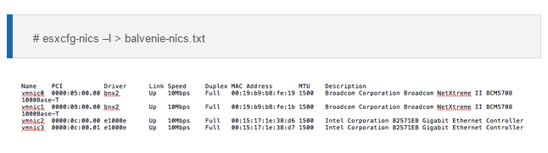

* To see all paths :  **#esxcfg-mpath -l**
* To check invisible LUNS : **#esxcfg-mpath -l |less**
* To rescan HBA for new LUNs : **#esxcfg-rescan**
* To get ESXi Route Table : **# esxcfg-route –l**

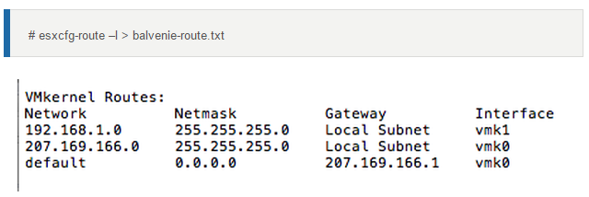

* Displaying ESXi host virtual network adapter information **:#esxcfg-vmknic -l**   
    
  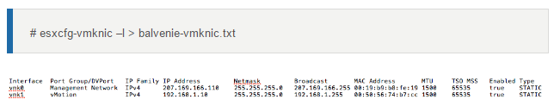
* Gathering virtual switch information **: #esxcfg-vswitch**

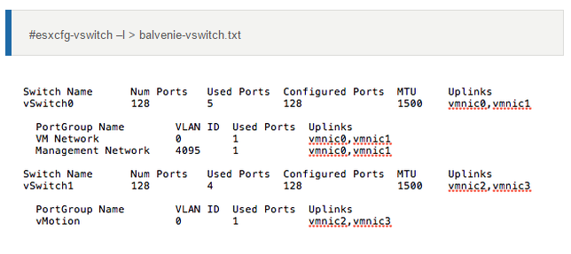   
  
  
**RECENT MAJOR SCENARIOS FOR INTERVIEW**

1. **Datastore contains 25 delta.vmdk files but in snapshot manager no snapshots?**

**CAUSES**:

We unable to consolidate the virtual machine snapshot disks due to below causes.  
  
(1) Due to Hidden and Stale delta vmdk; which were formed by snapshot creation and removal task failures in daily VM image level backups.  
  
(2) virtual machine backup solution creates a lock on a VMDK and fails to correctly release it is one of the cause to consolidation failures.

(3) The VMware host held a lock on that snapshot, typically due to a communication error between Veeam and the host/VC.

(4) Due to VSS in vmtools; virtual machine Image Level Snapshot Creation and Snapshot Removal task failing during backups.

**RESOLUTION**:

1) Need to create a new snapshot on the affected virtual machine and then Perform a **Delete All** from the snapshot manager to consolidate all snapshots. (Completed with errors as disk locked)

2) Regarding stale snapshot need to move the CBT (,Change Block Tracking files) files by connecting SSH and consolidate snapshots.

3) For vmdk locked we need to kill the locked vmdk process id / World-ID on VM with help of Kill -9 command for this I need root password to take SSH. (**KB-10051**)

We need to run the below command to locate which host(s) had the lock on the vmdk.

vmkfstools -D /vmfs/volumes/yourvolume/yourVM/yourlockedVM.vmdk

Example: #esxcli vm process kill --type=soft –world-id=1268395

Example:#kill -9 *PID*

4) Needs to be re-install tools without VSS by Custom method to avoid vm snapshot backup creation & removal task failures.

5) Need to perform svmotion and restart Hostd & Vpxa Agents then proceed on consolidation post manual snapshot creation.

6) Remove all hot-added disks from the Veeam VM then create manual snapshot and perform “Delete All” Operation. (Ensure remove disk from virtual machine not from delete disk)

**Note**: Solution 3 is recommended if the backup server is physical and 6 is for virtual.

1. **Unable to assign IP address when migrating virtual machine from Esxi 3.5 to 5.5?**

**Ans**: Need to upgrade VMware Tools and change Network Adapter to VMXNET3.

1. **Cluster Master host is down?**

**Ans:**

All Slaves will experience HA Failover failures . Hence election process will happen to elect new master the new master will initiate HA process to restart old master virtual machines since its acting as Slave .

1. **VM performance graphs are not populating?**

**Ans:**

**Reason1**: SQL communication port 1433 changed during any security Vulnerability task as 10001, so we need to update the same port at VCDB file in vCenter.

**Reason2**: The below stats related tables are full. Need to truncate.

VPX_HIST_STAT1,

VPX_HIST_STAT2,

VPX_HIST_STAT3,

VPX_HIST_STAT4,

VPX_SAMPLE_TIME1,

VPX_SAMPLE_TIME2,

VPX_SAMPLE_TIME3,

VPX_SAMPLE_TIME4.

1. **VM vmdk IDE want to increase ‘C’ drive in server 2003?**

Ans:

Need to change disk type IDE to LSI LOGIC SAS by connecting host SSH and open VM vmdk configuration by VI Editor.

Once we changed the disk type then we need to increase drive C: by the below any one of the methods.

1.Dellexpert Utility

2. V2V

3.Helper Virtual Machine Technique.

1. **ESXi high utilization? Investigation?**

**Ans:**

1.We will check the Host Available resource.

2. Check if any Balloning happening at host level.

3. Check the Host Firmware and Drivers versions.

1. **When master Esxi partially dead, what will happens?**

**Ans:**

All Slaves will experience HA Failover failures in critical state and there is no chance of election process to choose new master to overcome the situation so we need to restart the faulty master manually to recover the situation with new election master.Hence election process will happen to elect new master the new master will initiate HA process to restart old master virtual machines since its acting as Slave .

1. **Unable to extend vmdk?**

**Ans**: Due to Virtual Machine snapshot.

1. **Unable to do vmotion due to absolute VLAN’s are not prompted or vmotion failing at 14%?**

**Ans:**

We need to remove the Uplink from DVSwitch and re-add it back to switch after couple of minutes.

Now we can able to see absolute IP and finish the vMotion.

1. **VM is restarting regularly! Why**?

**Ans:**

Virtual Machine scheduled Snapshot Remove task is taking more time, which is causing VM unexpected reboot.

1. **Unable to add the host into vcenter**?

**Ans:**

Lockdown Mode Enabled and ESXi Shell is disabled.

1. **LUN’s / Datastores are visibling in all the Esxi in a cluster except one ESXi**?

**Ans:**

Causes:

1. Masking having an issue after SAN Upgradation.

2. Due to FC Switch issue we are not able to see the FC Devices, checked at FC BIOS.

3. ESXi HBA Firmware is older version, need to upgrade the latest version.

1. **Upgradation from ESXi 5.1 to 6.0 failed at 92%? Showing the message cannot run upgrade script on host**?

**Ans:**

* Due to /bootbank contains /State ID , so we need to clear /bookbank/state <ID>.
* Here we need to state.tgz folder to /var/tmp directory and reboot the host and proceed with upgradation

1. **Vm appears inaccessible in v center**?

**Ans:**

1. Might be Host disconnected from VC due to High resource utilization / High Network usage.

2. Storage disconnected to Host.

3. Port Group needs to check.

4. Needs to check the datastore available space.

1. **How do you troubleshoot Virtual Machine Backup failures in your infrastructure**?

**Ans:**

1. Will check the disk type Basic /Dynamic on compatibility check.

2. We will check the datastore free space to store snapshot and make sure allocate the respective Block size.

1. **How to export log bundle from the ESXi host**?

**Ans:**

1. Connect host by Putty.

2. Type the command #vm -support

3. The log will store in /var/tmp folder

4. Install WINSCP in your Local Machine .

5. Run WINSCP and enter Host IP and login details .

6. You can able to see /var/tmp folder in WINSCP, just drag and drop into local PC.

7. Forward to Vmware vendor with help of FTP & SFTP to investigate logs.

**MANAGER DISCUSSION AND TICKETING TOOL**

**ITIL [ Information Technology Infrastructure Library ]**

It is a framework for delivering, supporting and improving IT services.

ITIL can help you

1. Reduce it costs, increase quality and decrease risk.
2. Improve decision making.
3. Visibility to the total cost of ownership and utilization.
4. Increase productivity.
5. Provide clear and effective communication.

**TICKETING TOOLS**

**Can you explain about your ticketing tool?**

In current organization we are using Service NOW to support all request like Incident, SR, Change Request (CR) and Problem Tickets and supporting all these modules and also I have knowledge on BMC Remedy Tool as well.

We will be resolved all these tickets as per the SLA and taking responsibility on particularly on High and Critical cases and also participated in Critical management call whenever any P1 issue with the Client and provide resolution as well as will be prepared RCA and submit to the Client.

Majorly will take Responsibility of Daily Operation discussion calls and Weekly CAB Call with the client and participate in Internal DRS discussions with the team and preparing RCA’s

1. Service now (SNOW).
2. BMC Remedy.
3. Advance Help Disk (AHD/CA).

**TYPES OF TICKETS**

1. Incident.
2. Chang Ticket (CR\CO).
3. Problem Ticket.
4. Service Request (SR).
5. **INCIDENT**:-

When running server functionality broken or destroyed then we will receive incident.

**Ex:** Server shutdown or application not functioning or service stop or resource high utilization.

Most of the tickets will fall under Incident for the day to day activities approximately 60% tickets we will be closed.

What is an Incident?

If any production server interrupted / running application function broken then to fix the issue we can raise incident and simply it is outage for business.

Otherwise in simple terminology we can raise incident if something broken unexpectedly and interrupted running business.

Example: Server Down, Service Down, Server restart, performance issues etc….

**INCIDENT PRIORITY**:-

Critical /P1, P2, P3 P4.

Critical & P1 process is standard and similar for most of the customers in MNCs

**Server categaration:**

1. Production (P1 & Critical).
2. Development (P2&P3).
3. Testing (P4).

All Production servers receive P1 & critical.

SLA (Service Level Agreement).

Based upon SLA Table we can work this module.

**INCIDENT SLA DETAILS**:-

SEV1 –Response Time is 15 Mins and Resolution Time is 3 Hours (Critical Incident)

SEV2—Response Time is 1 Hour and Resolution Time is 6 Hours (High Priority incident)

SEV3—Reseponse Time is 4 Hours and Resolution Time is 24 Hours (Medium Priority Incident)

SEV4—Response Time is 8 Hours and Resolution Time is 2 Days.

**When P1 ticket came , we need to prepare RCA (Rout case analysis’s) and follow P1 Process.**

**Rout case analyses: Every P1 case will contain RCA & Change Ticket.**

**INCIDENT STAGES**:-

1. Assign----When the customer raised ticket / when monitoring server triggered alert.
2. Work in progress (Wip)---Action began on issue.
3. Resolution or resolved---Issue Fixed.
4. Pending ----If any pending with Customer / Vendor / supplier.
5. Closed—After Resolved the ticket will audit by Audit team then the case will be closed.

Pending Reasons:

* Wait for the customer action.
* Wait for vendor action.
* Wait for supplier
* Monitoring the server resources (High CPU & High Memory)

**2. CHANGE TICKET: -**

If you going to make any changes on existing infrastructure then we should go with CR; basically CR can be happen by Incident all CR’s can be reviewed by Change Manager. We will follow all CR Plans such as

1. Business Justification
2. Implementation Plan
3. Test Plan
4. Backout Plan
5. Scheduled Window
6. Downtime Window
7. Involved Resources like other team (Network, Security, Windows, Database team etc..)

Ex: 1) Reconfiguring server resources.

2) Restarting server.

3) Remodifying the server.

4) Installing patches.

5) Installing third party application.

6) Upgrading the server.

7) Upgrading the H/W & Firmware.

**CHANGE TICKET / ORDER STAGES**:-

1. REQUESTED : CO Creation initial phase.
2. PLANNED : Server / Application owner acceptance.
3. AUTHORIZED : Customer / CAB Approval (BASF Change Board Team Approval)
4. BUILDING : Action needs to be performing accordingly.
5. TESTING : Test the Actions status, means all tasks are performed perfectly or not
6. APPROVED : Approved as work is done perfectly.
7. INSTALLED : After action and Test then will move to installed as completed
8. VERIFIED : All Ground Level checks and verifications has been done as everything is in

intact state.

When we create CR [Change Request] we need to follow the bellow

1. **Change Type:** Standard / Minor / Major / Emergency CR. We have 4 types of changes.

**( A) Standard change:-**

Where we does not required the customer approval for CR implementation then we will raise standard change

**Example**: Schedule reboots as recommended by Microsoft.

**( B) Major change:-**

If any downtime is required for the production servers during any reconfiguration and in maintenance windows then we will be create Major CR. Always we will create Major CR for production critical servers.

**Major change phases:**

1. Business justification. [ Why we need to implement this change ]

**Ex:** SAP Team requested changes as recommended by application vendor.

1. Implementing plane . [ How you going to implement ]

**Ex**: ESXi Upgradation with help of Update Manager.

1. Backout plan : What type of backup it is **Ex**: Snapshot, Clone, Host profile
2. Test plane : Is this change has been tested on test infra or not.
3. Schedule window (which Time): Schedule Start Time & Schedule End Time.
4. Down Time Window: What is exactly Start and End Downtime windows.
5. Onsite supporting team contact details.

**(C )** **Emergence Change Request ERC**:

During Critical Business outages to fix immediately we will be raise ECR.

**NOTE**: Major change and ECR change we need Customer Approval in Weekly CAB call to proceed.

**(D)** **Minor Change** : it is equal to Standard Change.

**3.PROBLEM TICKET:-**

Reoccurrence of issue or repeating issues then we will raise problem ticket to fix permanently.

Problem ticket won’t contain SLA.

Every problem ticket contains the change ticket.

**4.What is SR (Service Request):-**

There is no interrupt and service down issue but need some additional information to proceed for operations is called SR.

Example: Adding user phone number in Existing User account, install additional plug ins , provide additional access on the existing application etc..

What is Difference between Incident and SR?

Incident have downtime to your Server

No Downtime for your SR.

**SUGGESTIONS AND RECOMMENDATIONS**

__________________________***END***___________________________________